***TRAVEL AGENCY WEBSITE***

**Project Members** :-

Dayal Thakur

Shubham Shinde

Yash Warke

**Introduction :-**

The "Travel Agency Website" has been developed to overcome the problemsprevailing in the practicing manual system. This software is supported to eliminate and, in some cases, reduce the hardships faced by this existing system. Moreover, this system is designed for the particular need of the company to carry out operations in a smooth and effective manner.

The application is reduced as much as possible to avoid errors while entering the data. It also provides error message while entering invalid data. No formal knowledge is needed for the user to use this system. Thus by this all it proves it is user-friendly. Travel Website, as described above, can lead to error free, secure, reliable and fast management system. It can assist the user to concentrate on their other activities rather to concentrate on the record keeping. Thus it will help organization in better utilization of resources.

Every organization, whether big or small, has challenges to overcome and managing the information of Tour, Travel, Hotel, Customer, Facility. Every Travel Website has different Travel needs, therefore we design exclusive employee management systems that are adapted to your managerial requirements. This is designed to assist in strategic planning, and will help you ensure that your organization is equipped with the right level of information and details for your future goals. Also, for those busy executive who are always on the go, our systems come with remote access features, which will allow you to manage your workforce anytime, at all times. These systems will ultimately allow you to better manage resources.

**Objective :-**

The main objective of the Project on Travel Website is to manage the details of Travel, Tour, Agent, Hotel, Facility. It manages all the information about Travel, Customer, Facility. Travel. The project is totally built at administrative end and thus only the administrator is guaranteed access. The purpose of the project is to build an application program to reduce the manual work for managing the Travel, Tour, Customer, Agent. It tracks all the details about the Agent, Hotel, Facility.

**Scope :-**

It may help collecting perfect management in details. In a very short time, the collection will be obvious, simple and sensible. It will help a person to know the management of passed year perfectly and vividly. It also helps in current all works relative to Travel Website. It will be also reduced the cost of collecting the management & collection procedure will go on smoothly

**Azure Services Used :-**

1. Azure VM:

Azure virtual machines are one of several types of [on-demand, scalable computing resources](https://learn.microsoft.com/en-us/azure/architecture/guide/technology-choices/compute-decision-tree) that Azure offers. Typically, you choose a virtual machine when you need more control over the computing environment than the other choices offer. This article gives you information about what you should consider before you create a virtual machine, how you create it, and how you manage it.

An Azure virtual machine gives you the flexibility of virtualization without having to buy and maintain the physical hardware that runs it. However, you still need to maintain the virtual machine by performing tasks, such as configuring patching, and installing the software that runs on it.

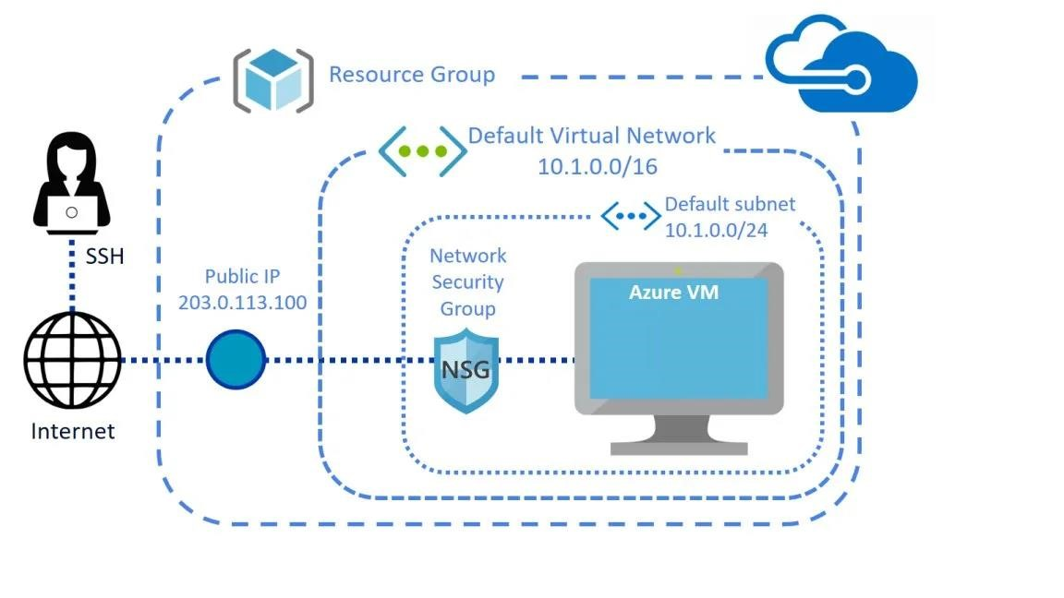

Azure virtual machines can be used in several ways. Some examples are:

* + Development and test – Azure virtual machines offer a quick and effortless way to create a computer with specific configurations required to code and test an application.
  + Applications in the cloud – Because demand for your application can fluctuate, it might make economic sense to run it on a virtual machine in Azure. You pay for extra virtual machines when you need them and shut them down when you don’t.

Extended datacentre – virtual machines in an Azure virtual network can easily be connected to your organization’s network

1. Load Balancer :-

Load balancing refers to efficiently distributing incoming network traffic across a group of backend servers or resources.

Azure Load Balancer operates at layer 4 of the Open Systems Interconnection (OSI) model. It's the single point of contact for clients. Load balancer distributes inbound flows that arrive at the load balancer's front end to backend pool instances. These flows are according to configured load-balancing rules and health probes. The backend pool instances can be Azure Virtual Machines or instances in a Virtual Machine Scale Set.

A public load balancer can provide outbound connections for virtual machines (VMs) inside your virtual network. These connections are accomplished by translating their private IP addresses to public IP addresses. Public Load Balancers are used to load balance internet traffic to your VMs.

An internal (or private) load balancer is used where private IPs are needed at the frontend only. Internal load balancers are used to load balance traffic inside a virtual network. A load balancer frontend can be accessed from an on-premises network in a hybrid scenario.

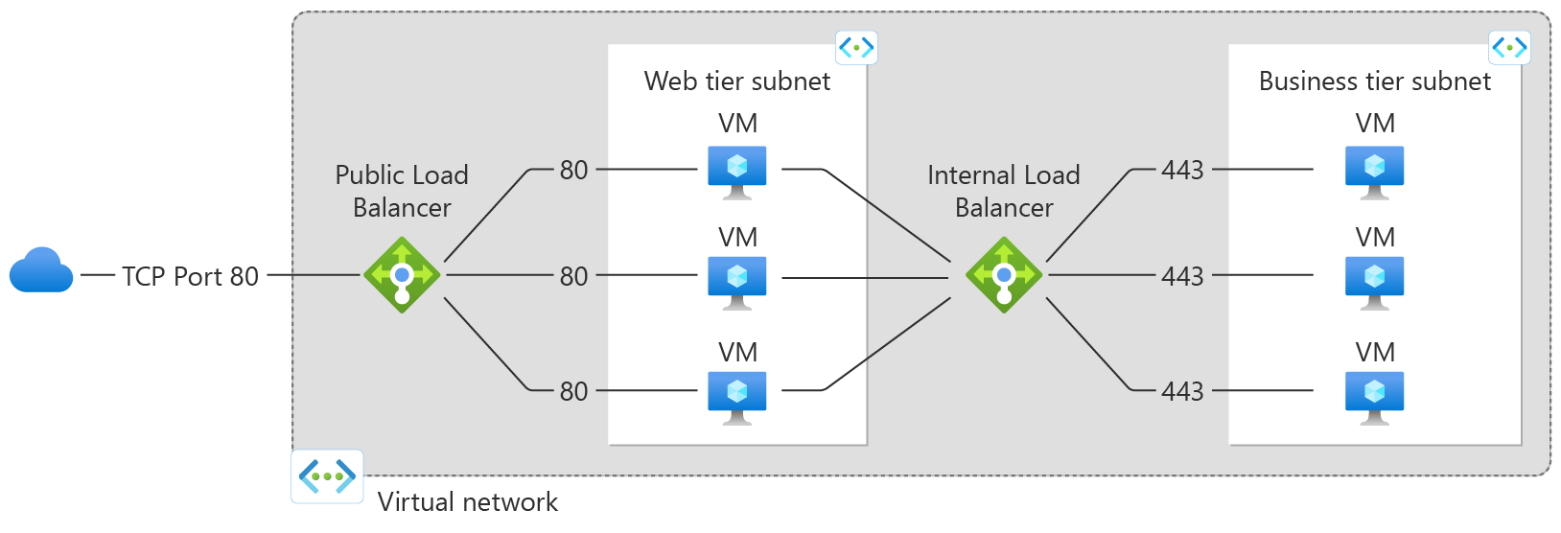

1. Virtual Machine Scale Set :-

Azure Virtual Machine Scale Sets let you create and manage a group of load balanced VMs. The number of VM instances can automatically increase or decrease in response to demand or a defined schedule. Scale sets provide the following key benefits:

* Easy to create and manage multiple VMs
* Provides high availability and application resiliency by distributing VMs across availability zones or fault domains
* Allows your application to automatically scale as resource demand changes
* Works at large-scale

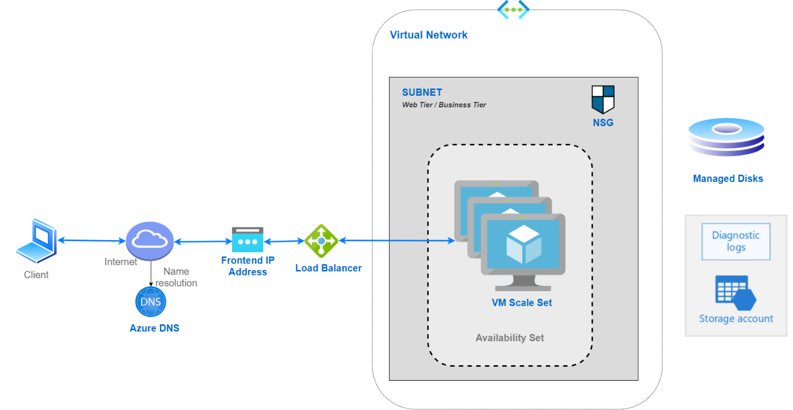

With Flexible orchestration, Azure provides a unified experience across the Azure VM ecosystem. Flexible orchestration offers high availability guarantees (up to 1000 VMs) by spreading VMs across fault domains in a region or within an Availability Zone. This enables you to scale out your application while maintaining fault domain isolation that is essential to run quorum-based or stateful workloads, including:

* Quorum-based workloads
* Open-source databases
* Stateful applications
* Services that require high availability and large scale
* Services that want to mix virtual machine types or leverage Spot and on-demand VMs together
* Existing Availability Set applications

**Implementation:-**

Search the Azure Portal on browser and login with credentials.

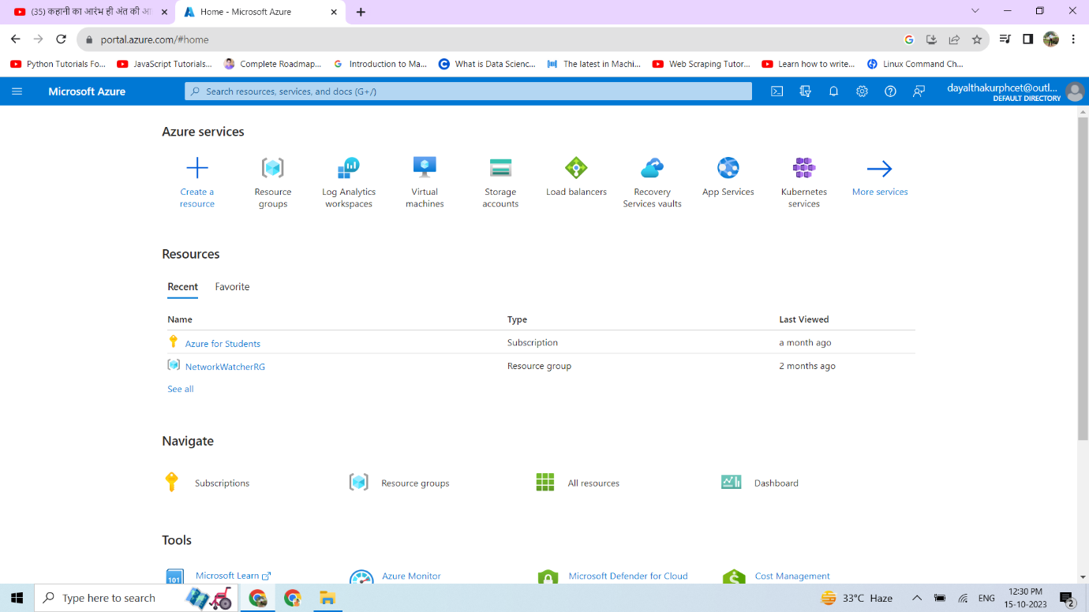

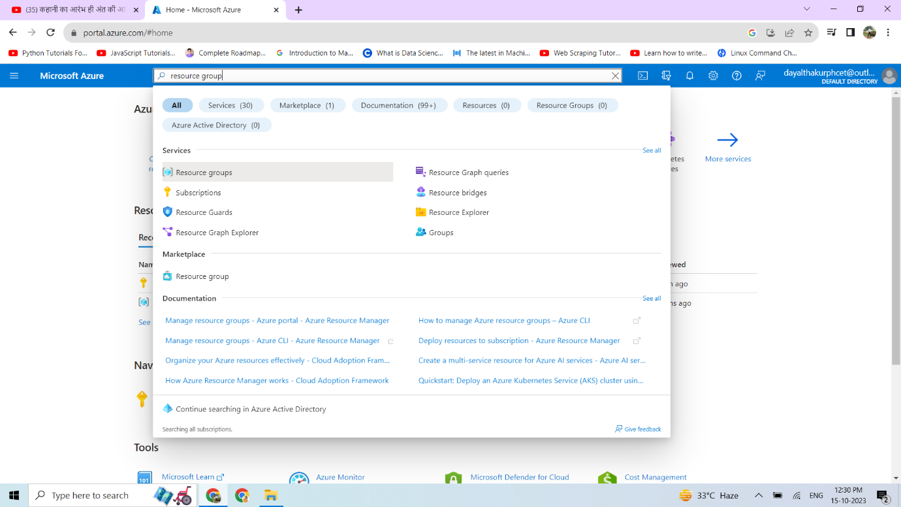After login Search Azure Service that we are using i.e Resource Group

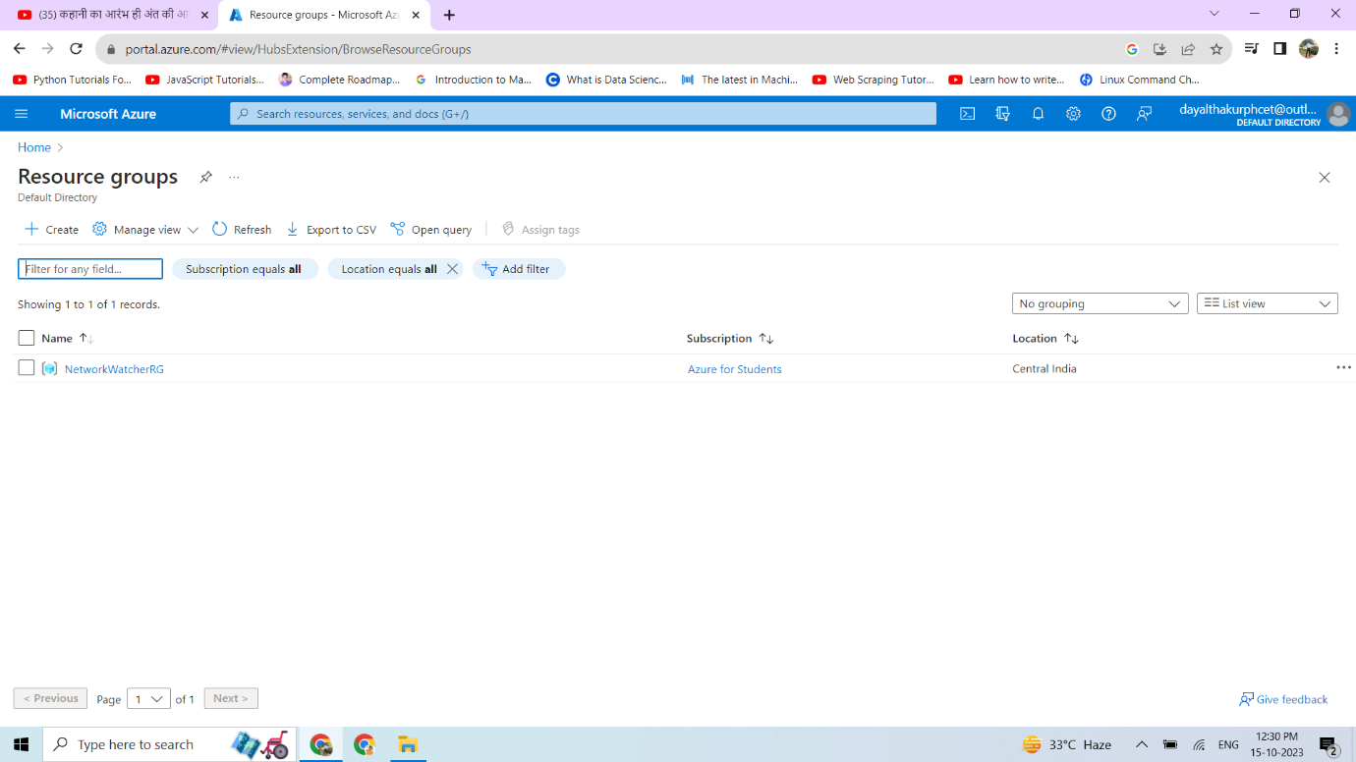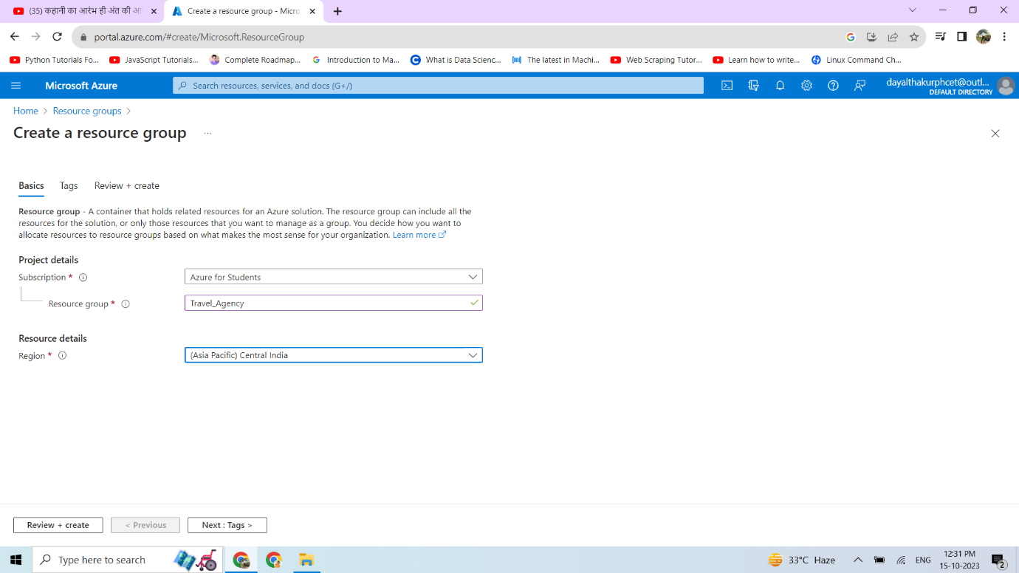

We are creating an Resource Group which hold the all services that we are using for our project

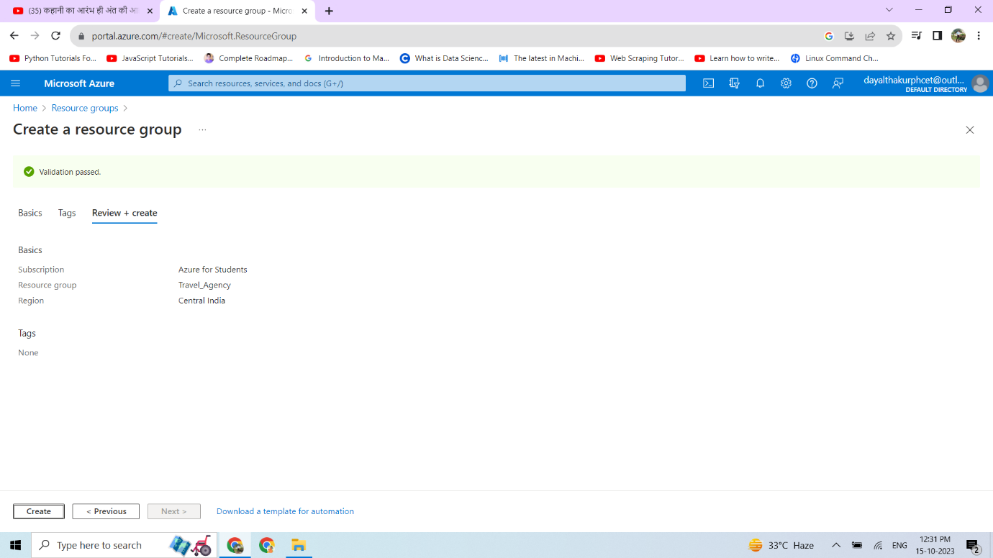As we see here Resource Group is created successfully

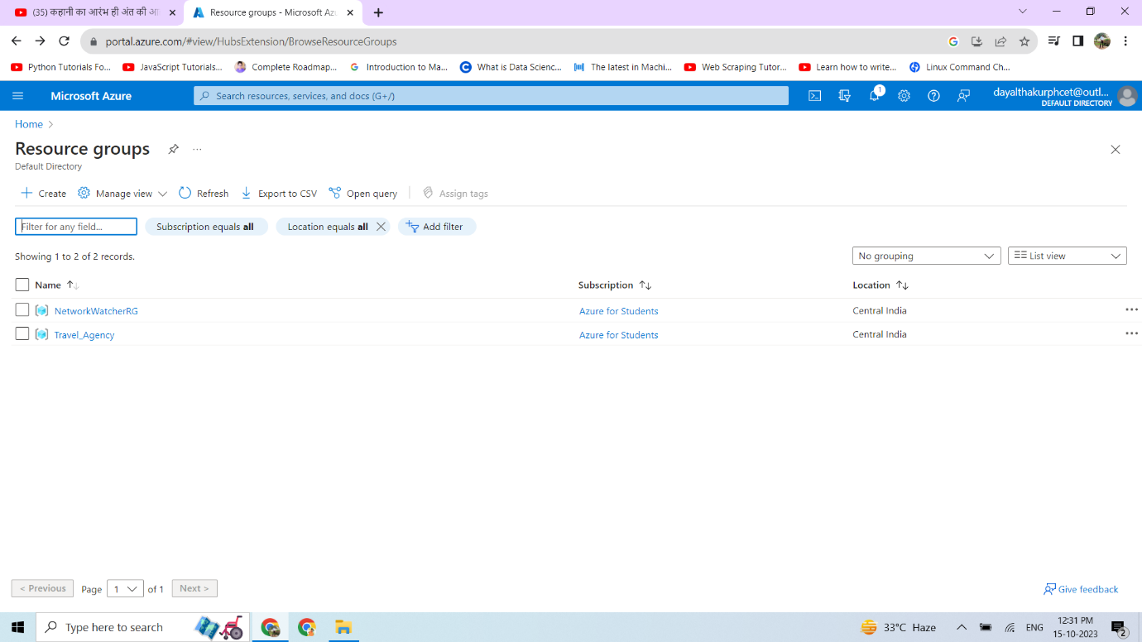We can see created resource group named as **Travel_Agency**

Now we are creating next Azure service i.e. Virtual Machine

For that search, the virtual machine on azure portal search bar.

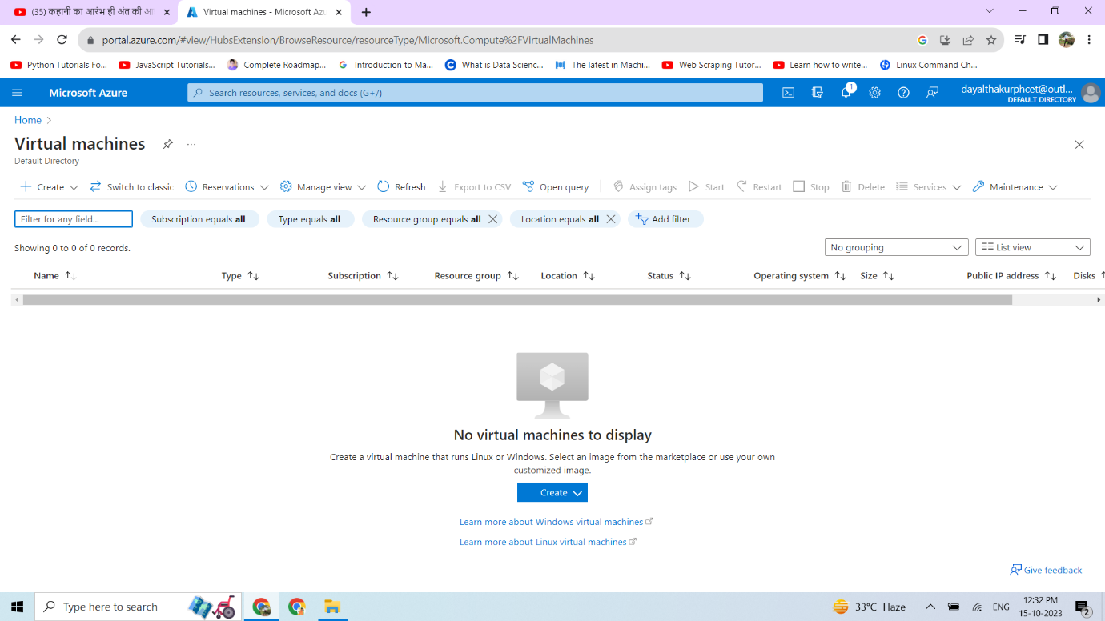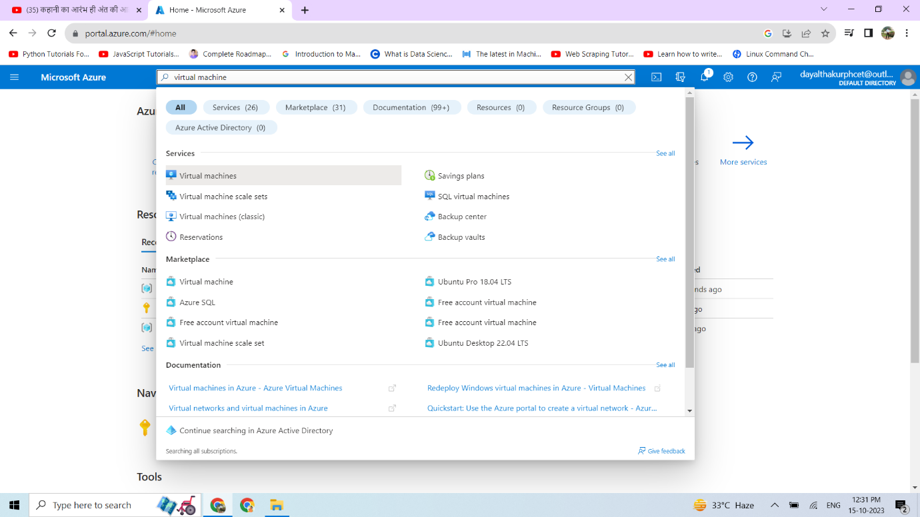

To create virtual machine click on the CREATE button.

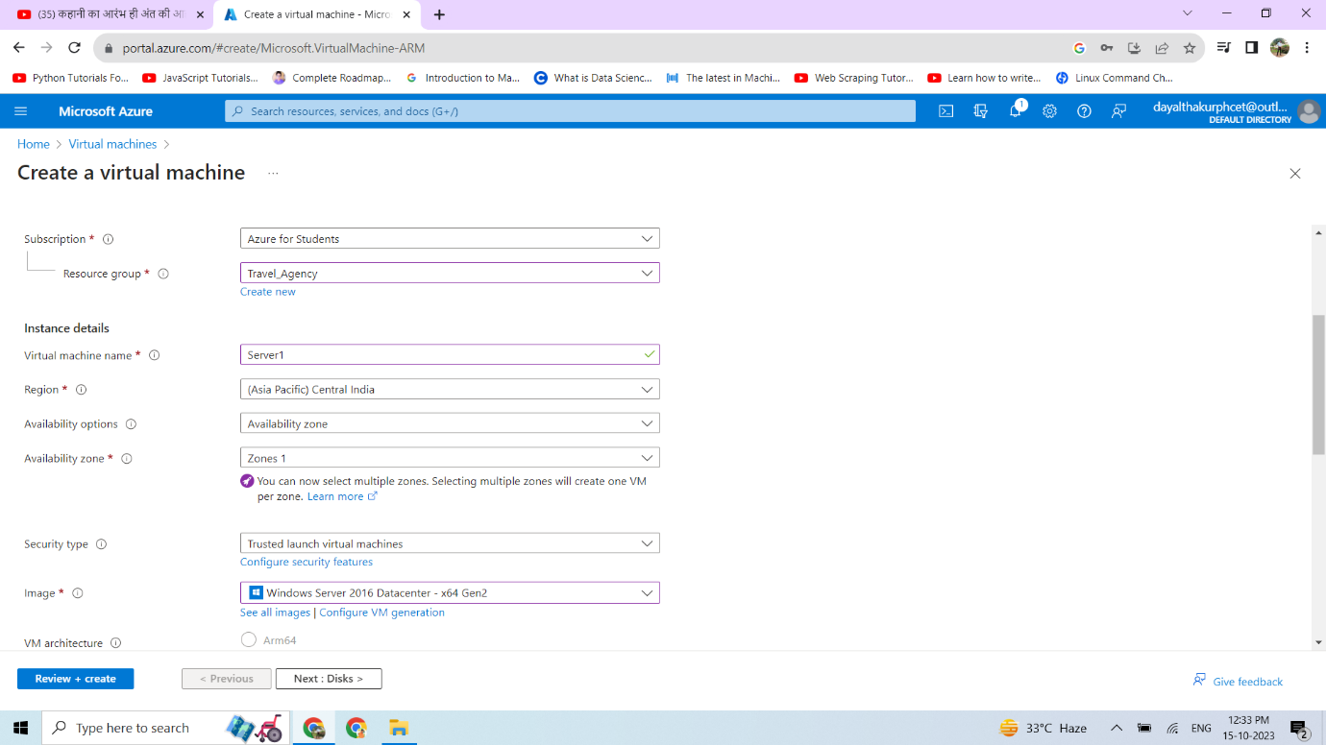Fill the required Information.

VM name -> Region -> Availability options -> Image -> Give username and password -> Select inbound ports.

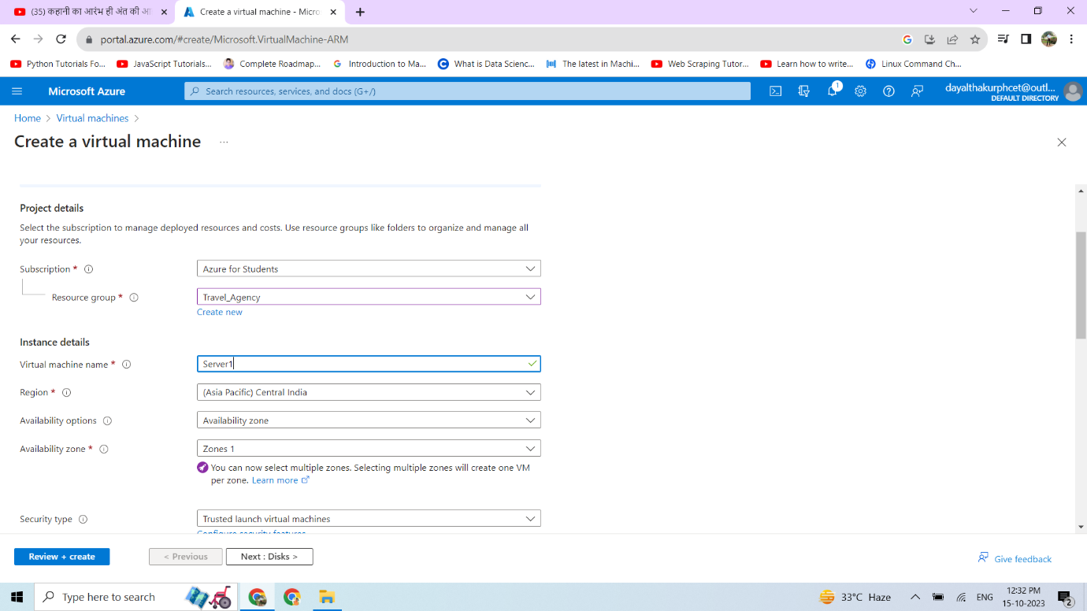

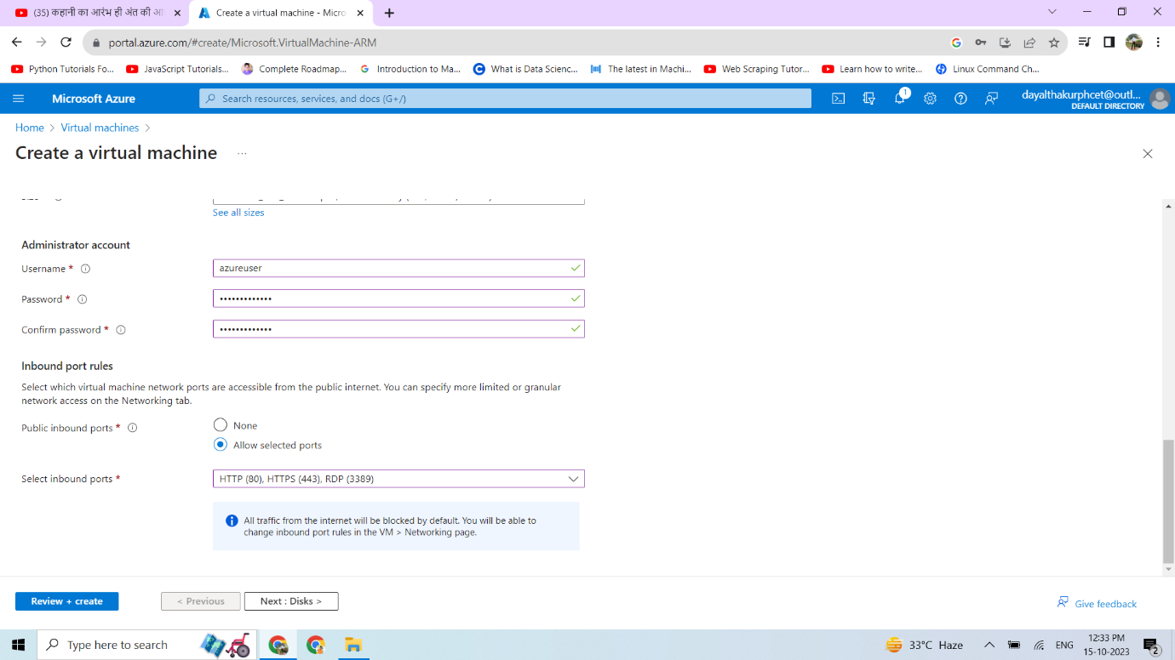

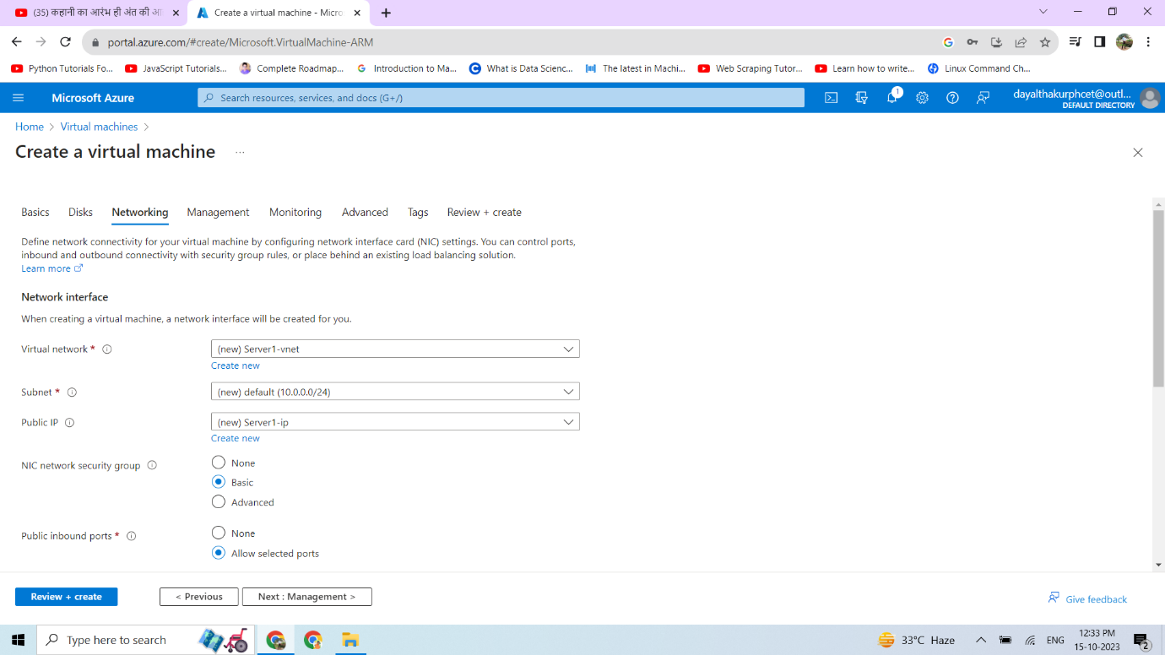

Now we can create load balancer click on create new.

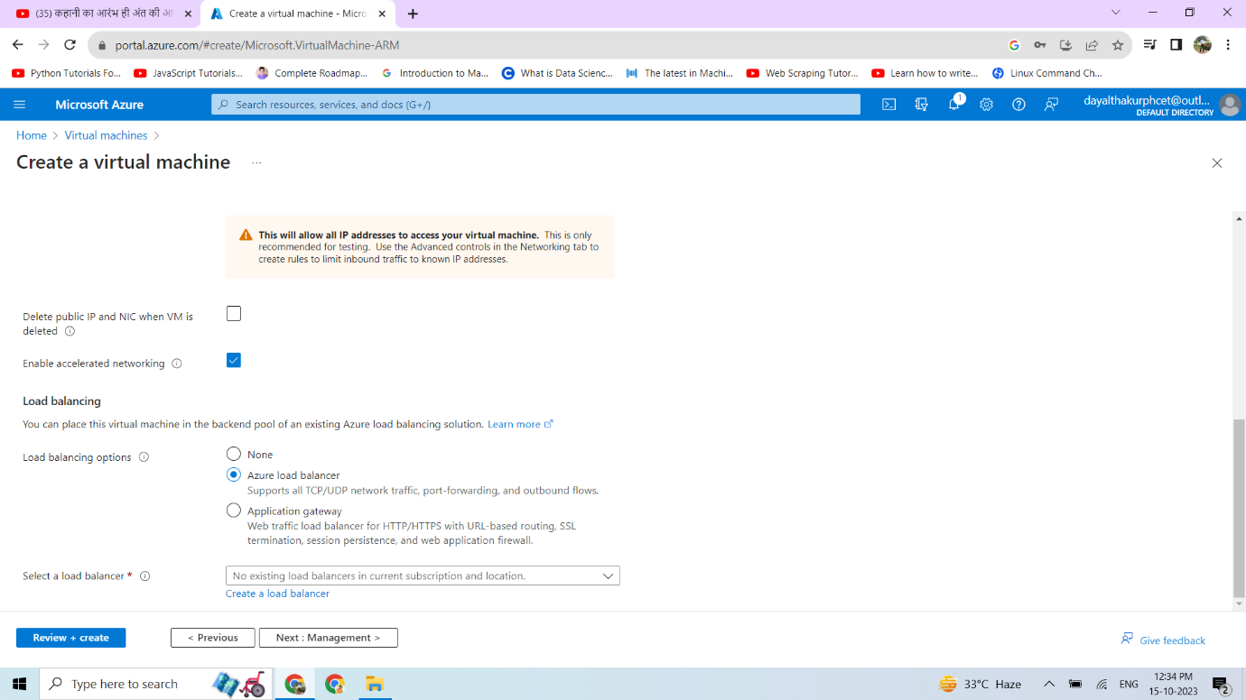

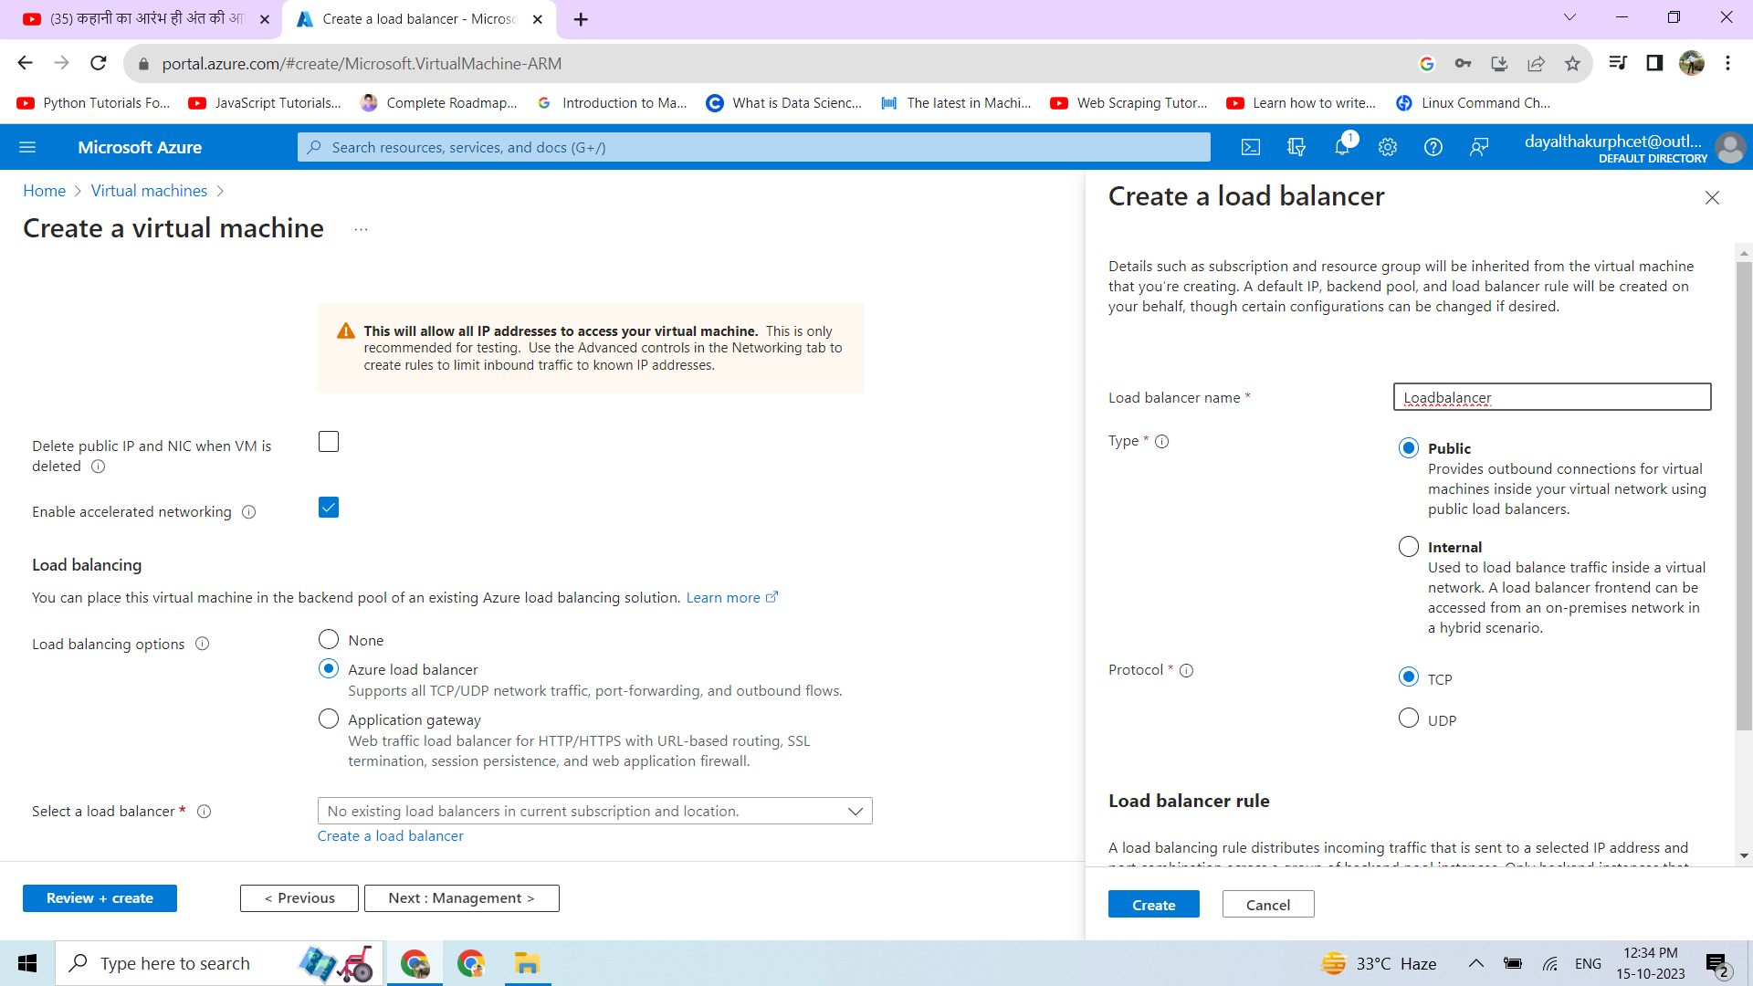Give the load balancer name and keep the settings to default.

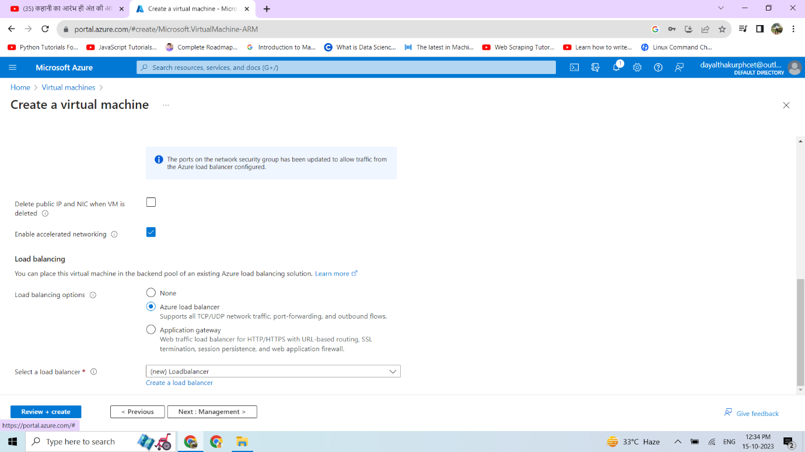

Click on CREATE to create VM.

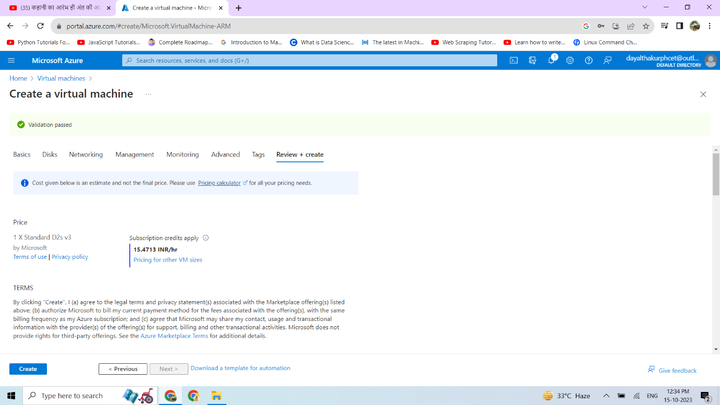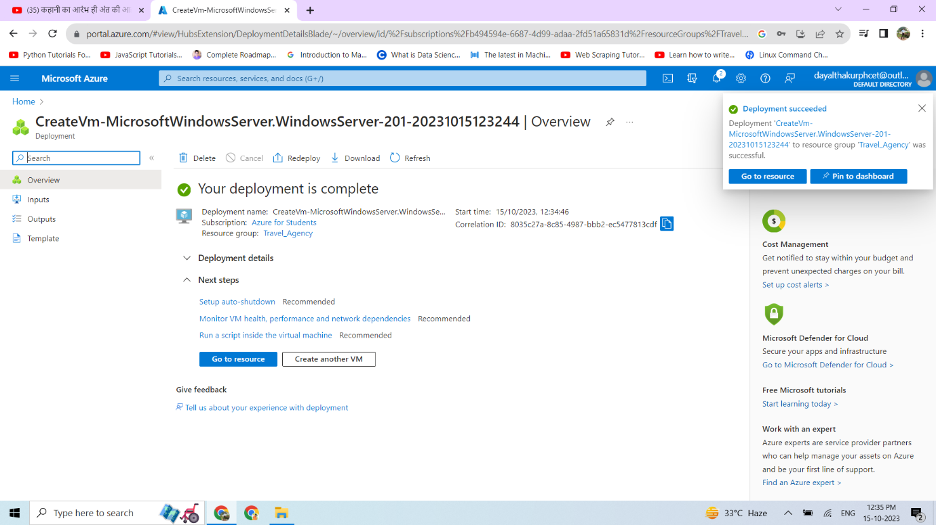

As we see Deployment of VM is completed.

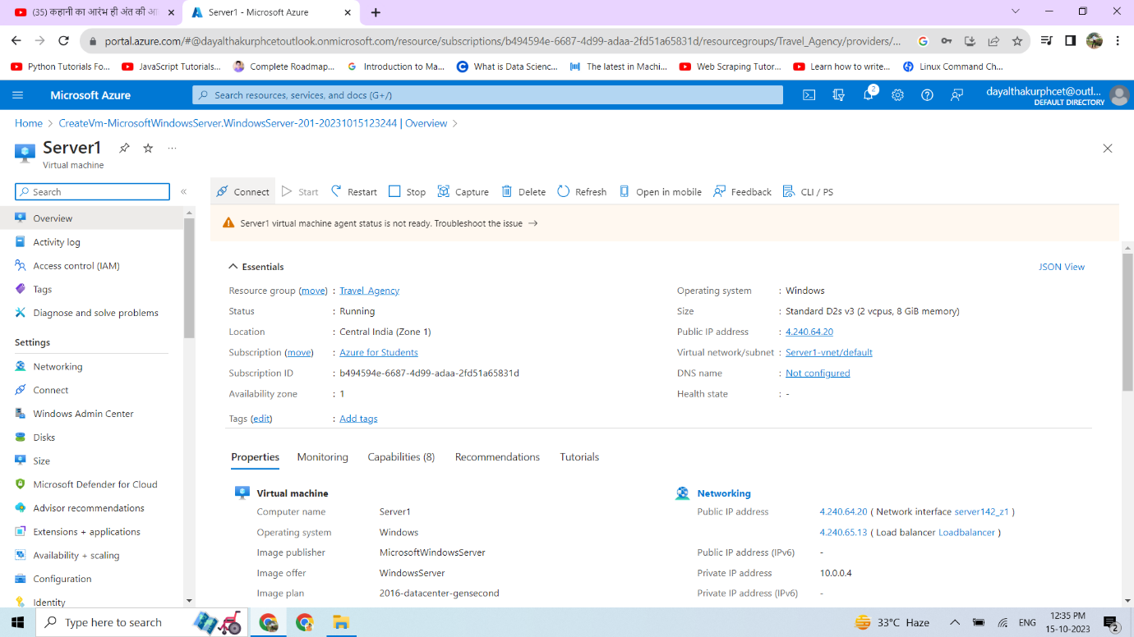

Now we connect Virtual machine using the RDP file

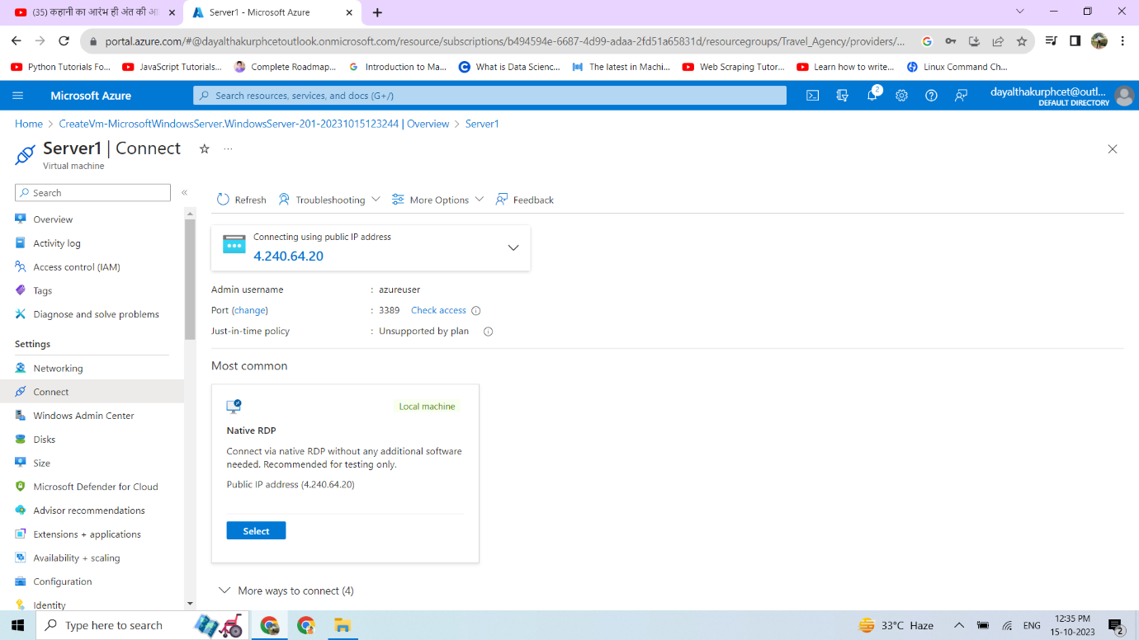

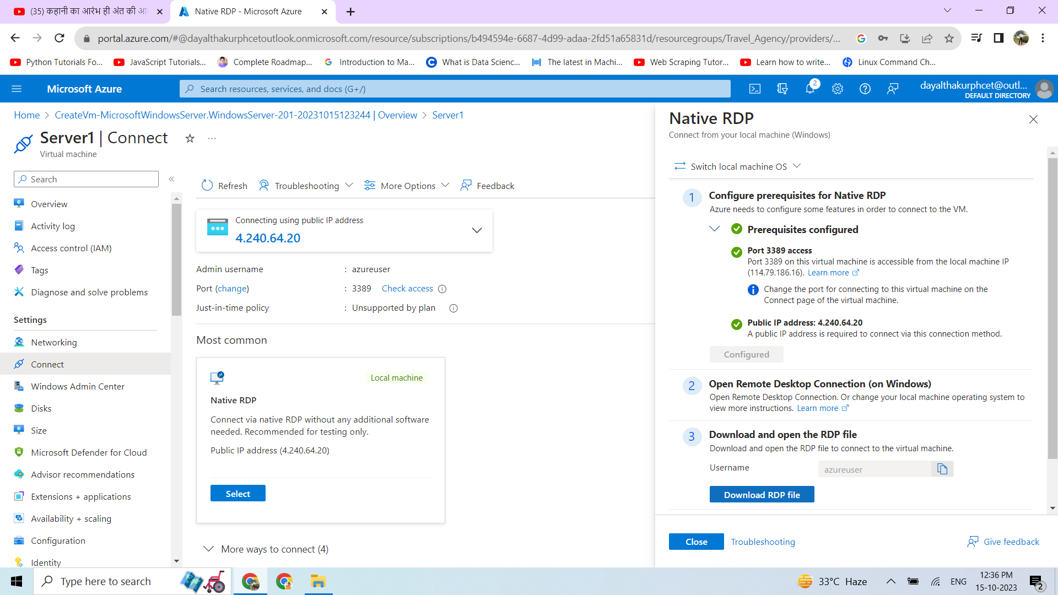

Now We connect using VM credentials.

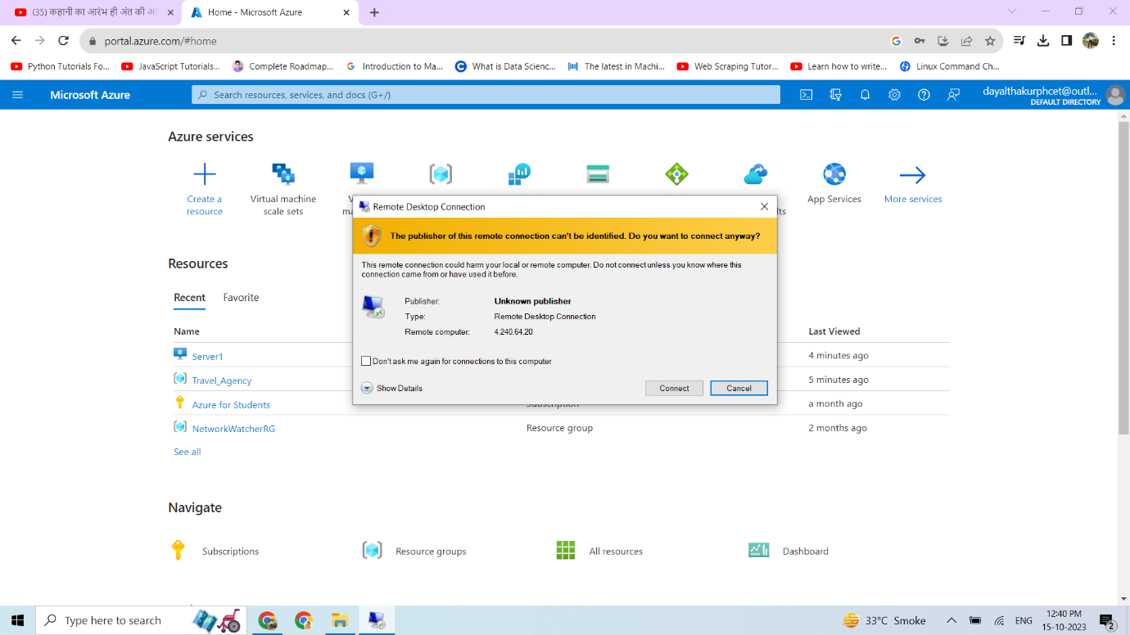

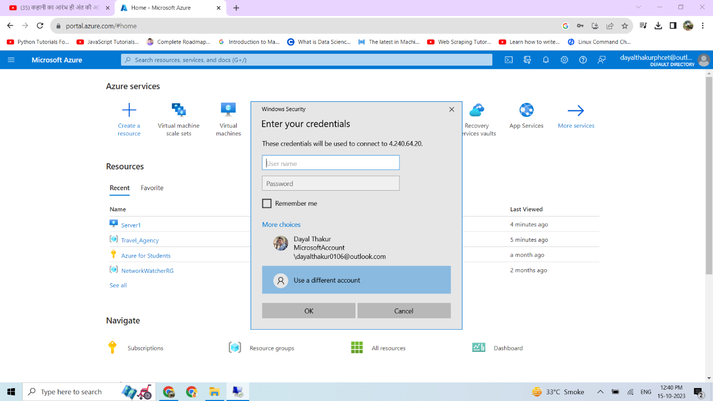

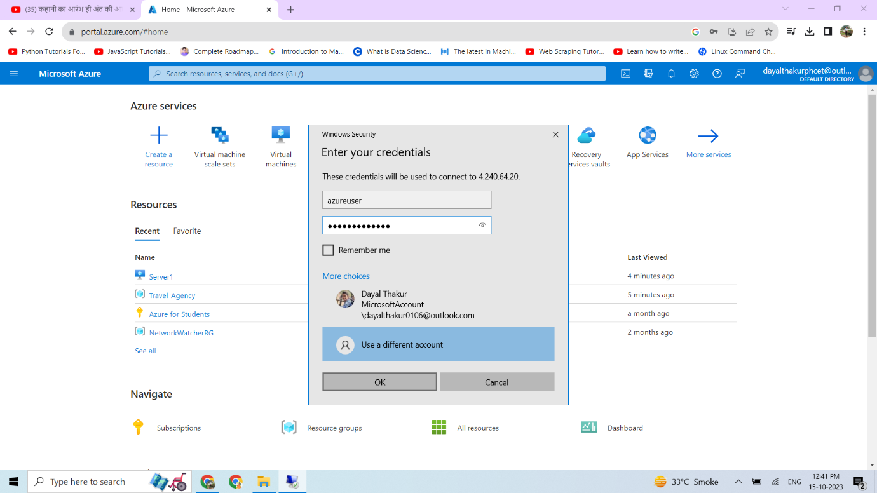

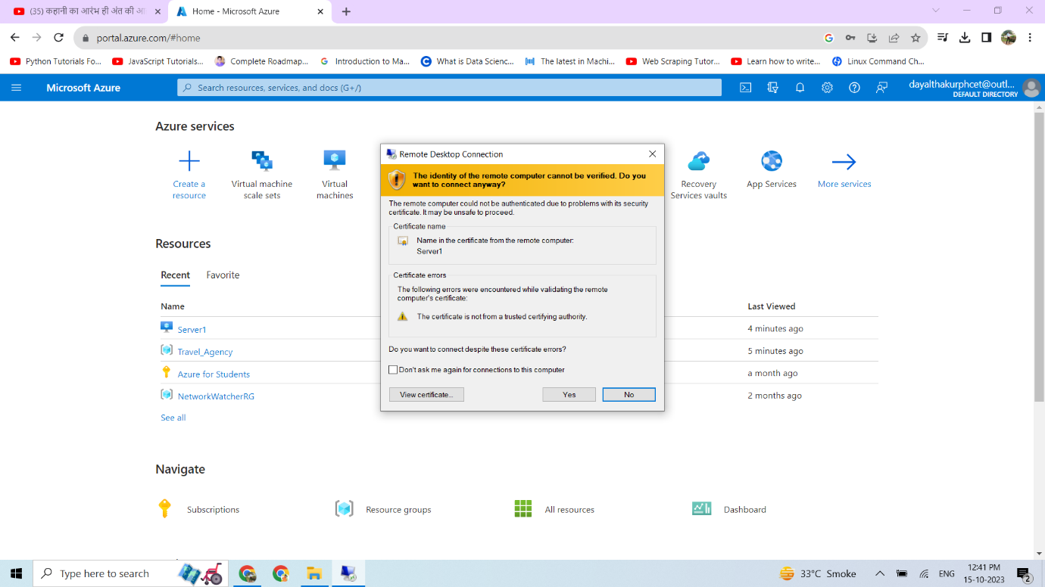

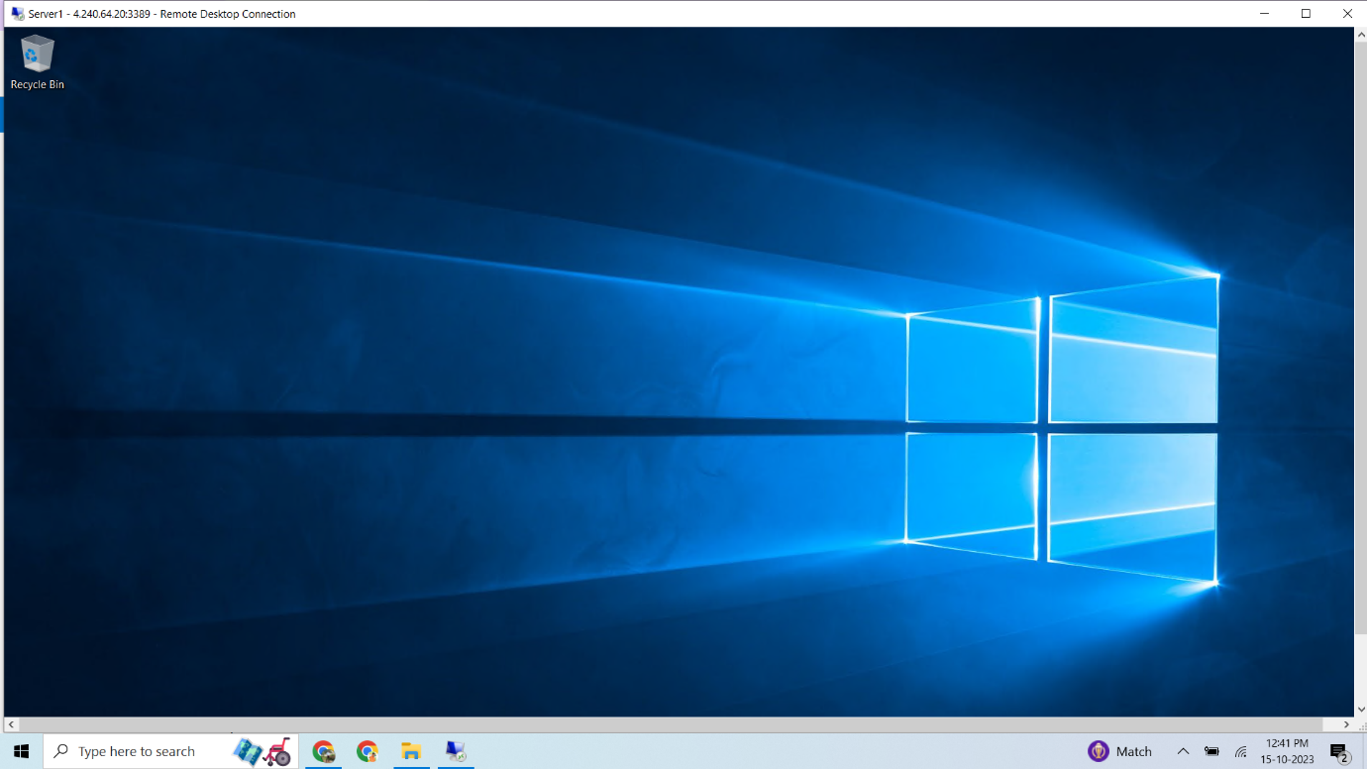We successfully Connect to the Virtual Machine.

Now, we open Server manager and Add Web service feature

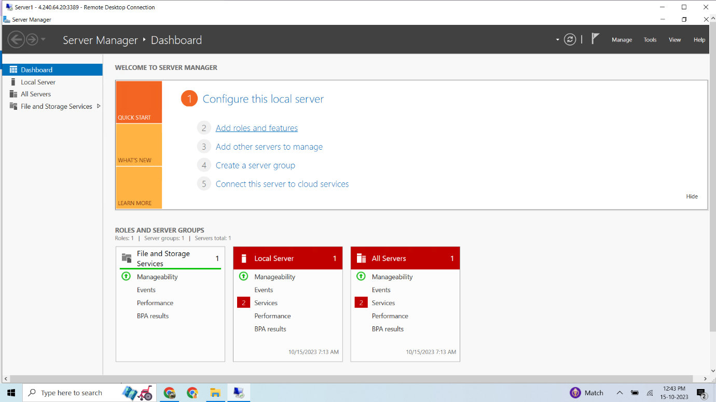

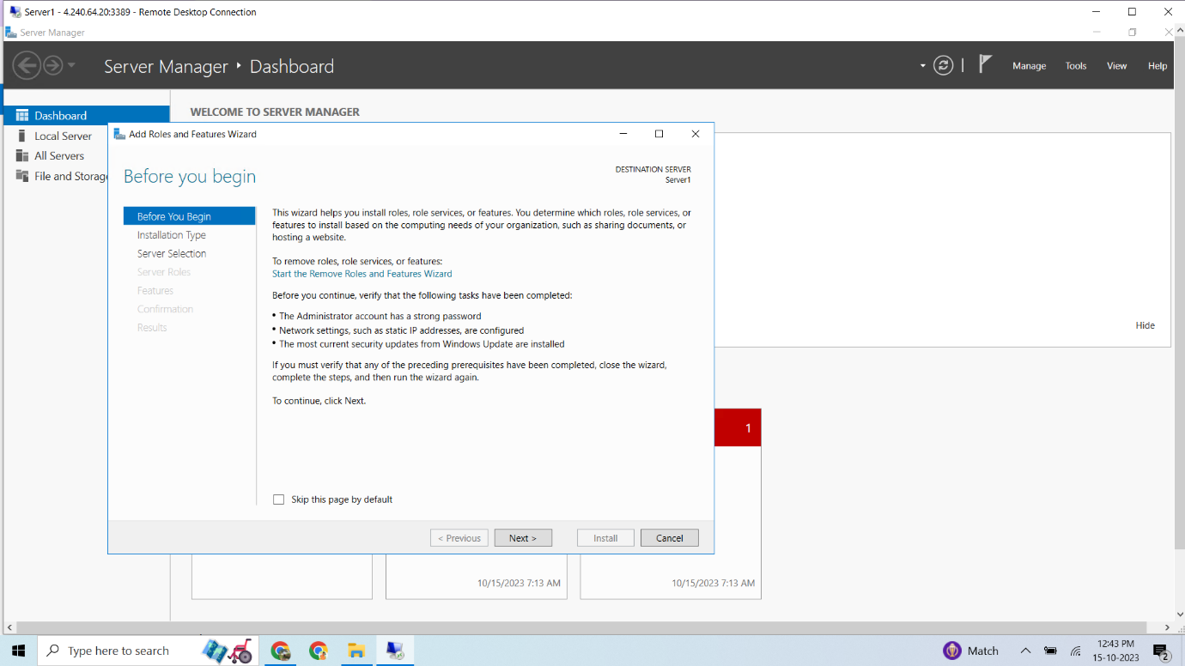

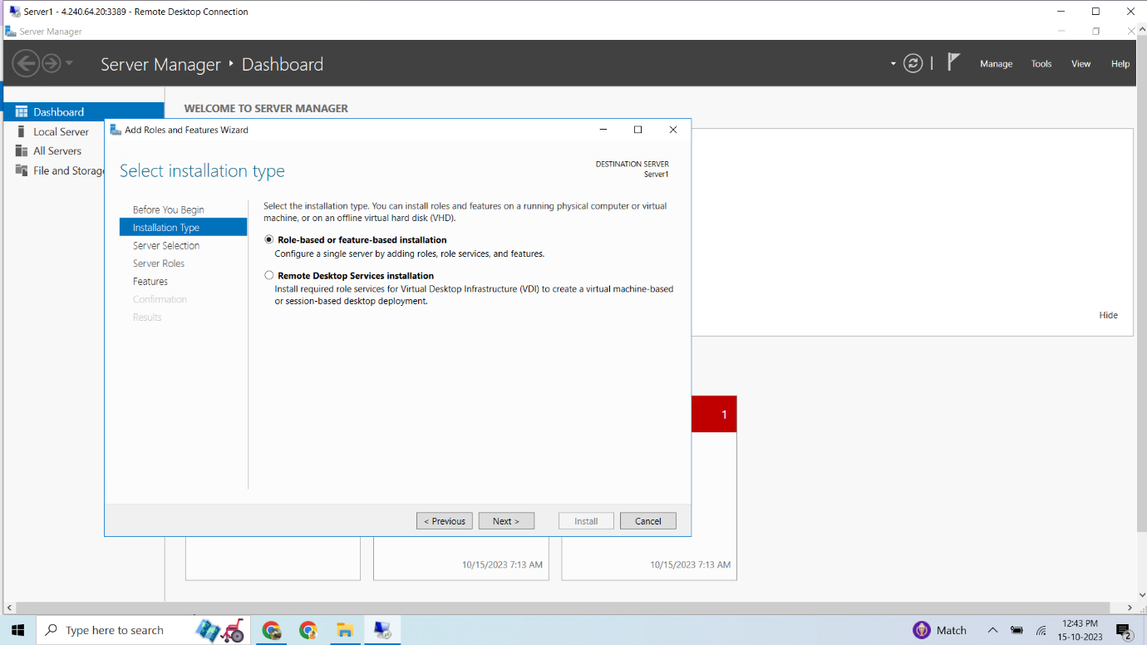

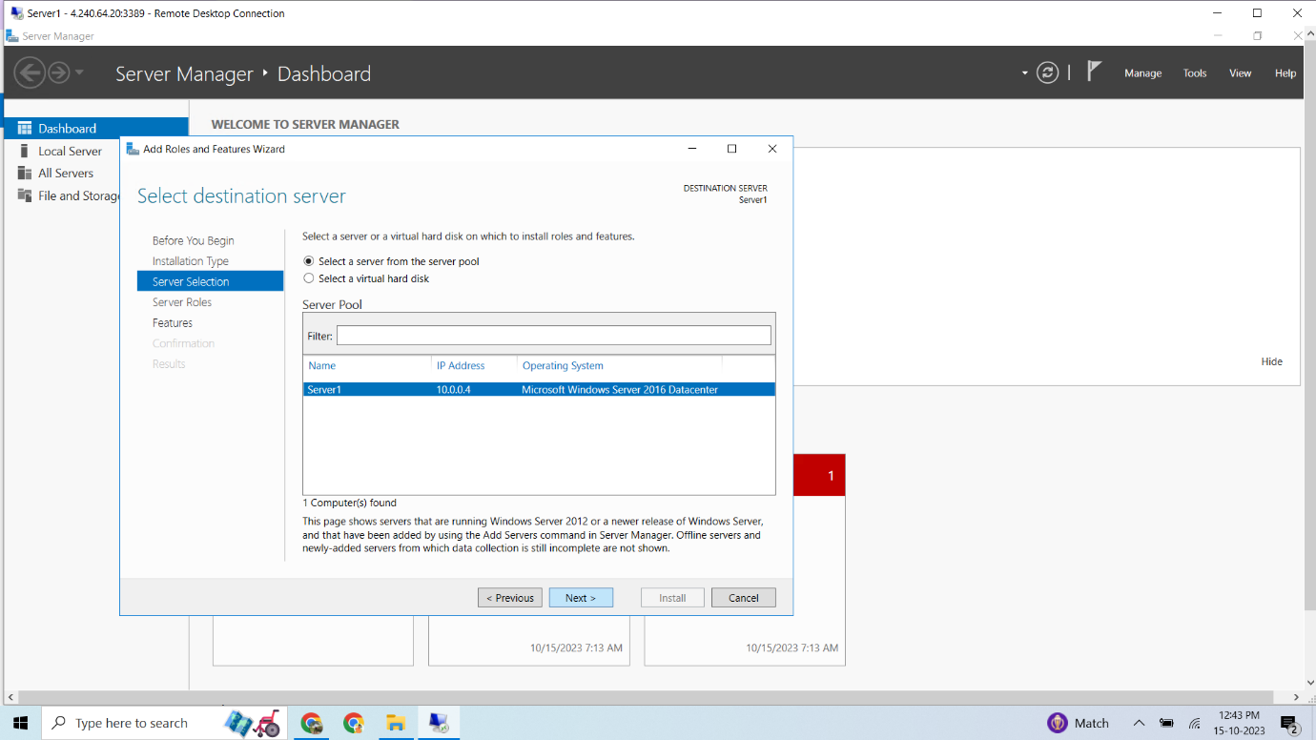

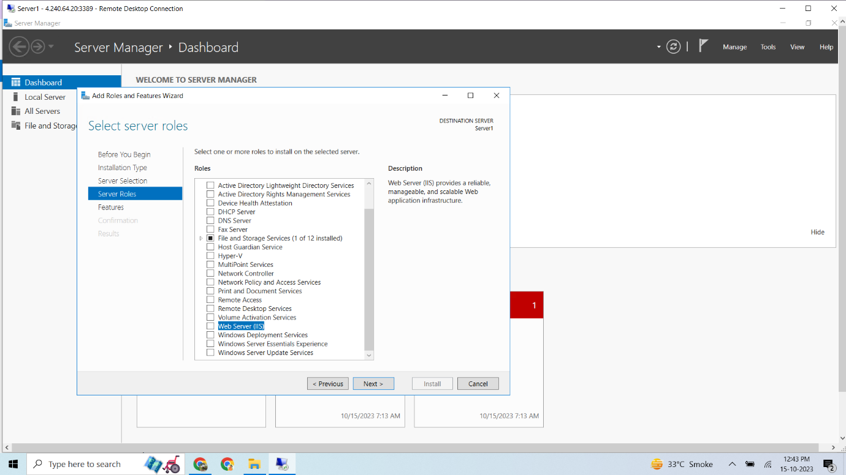

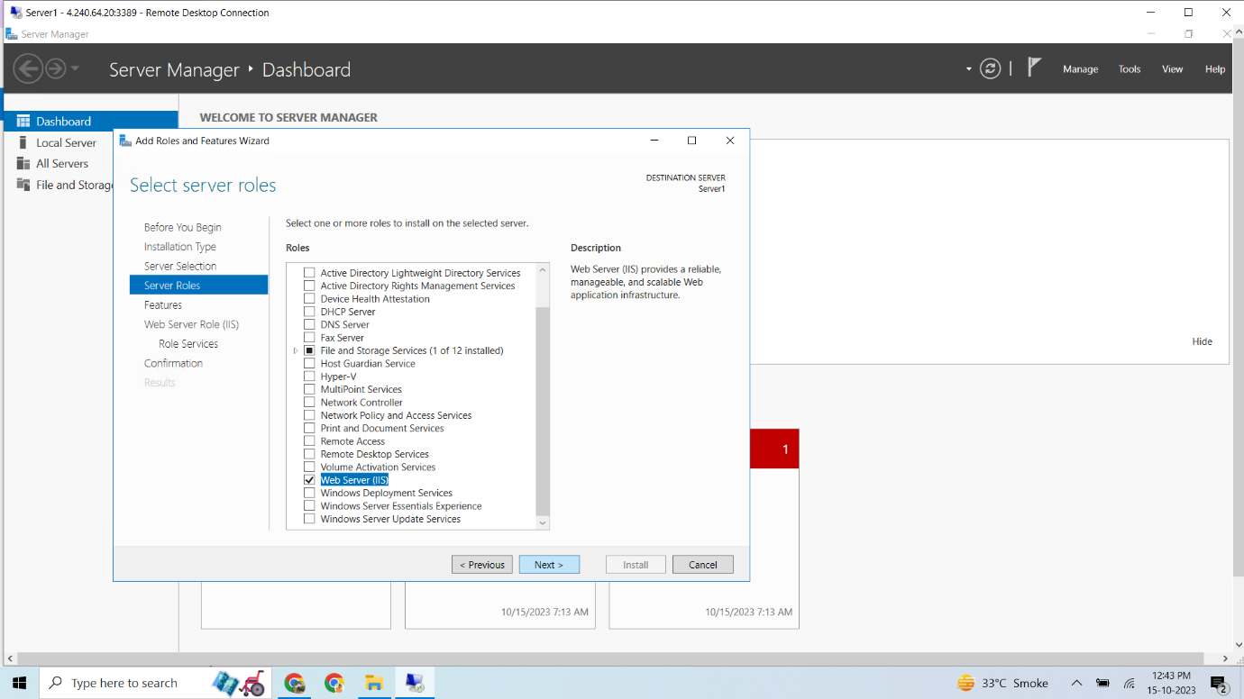

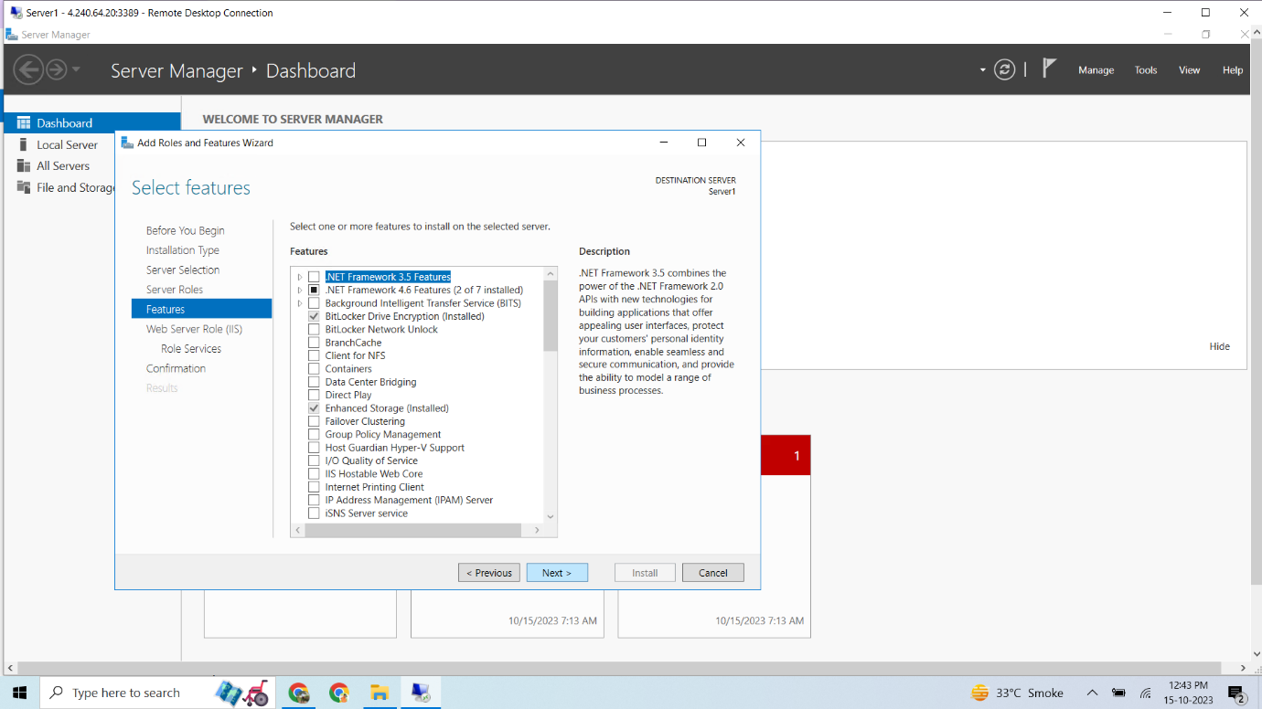

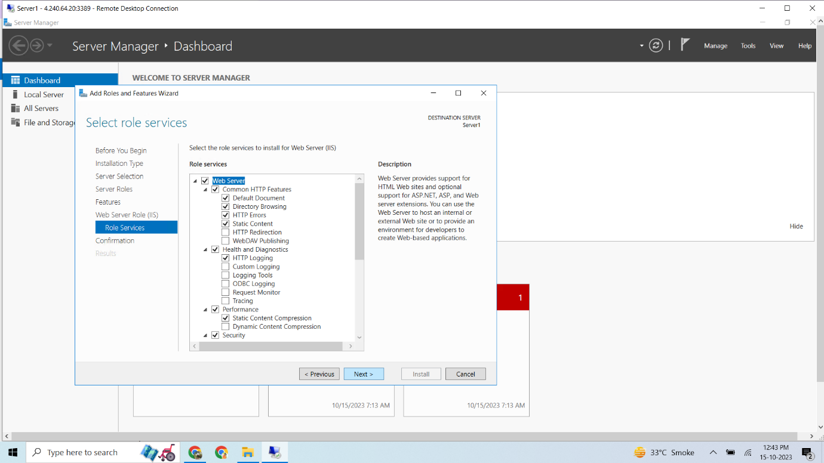

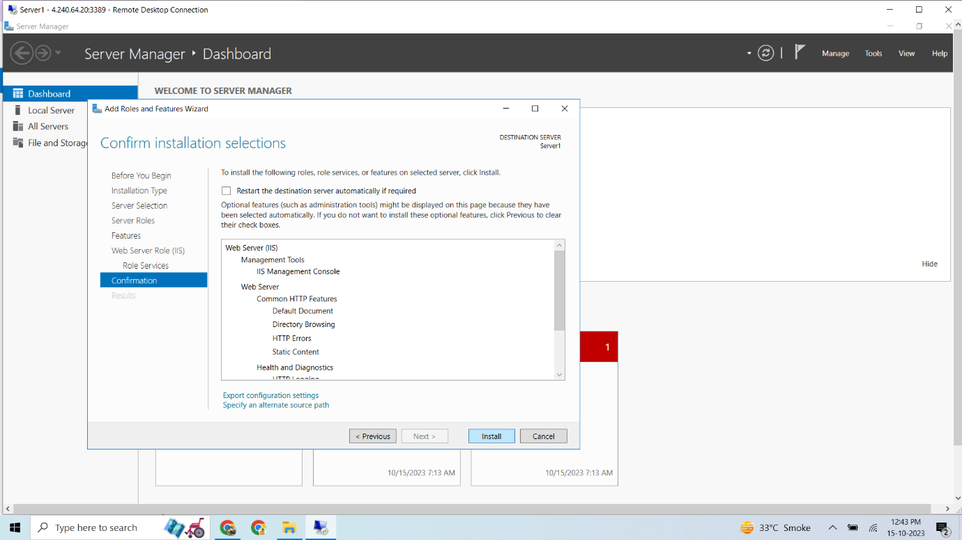

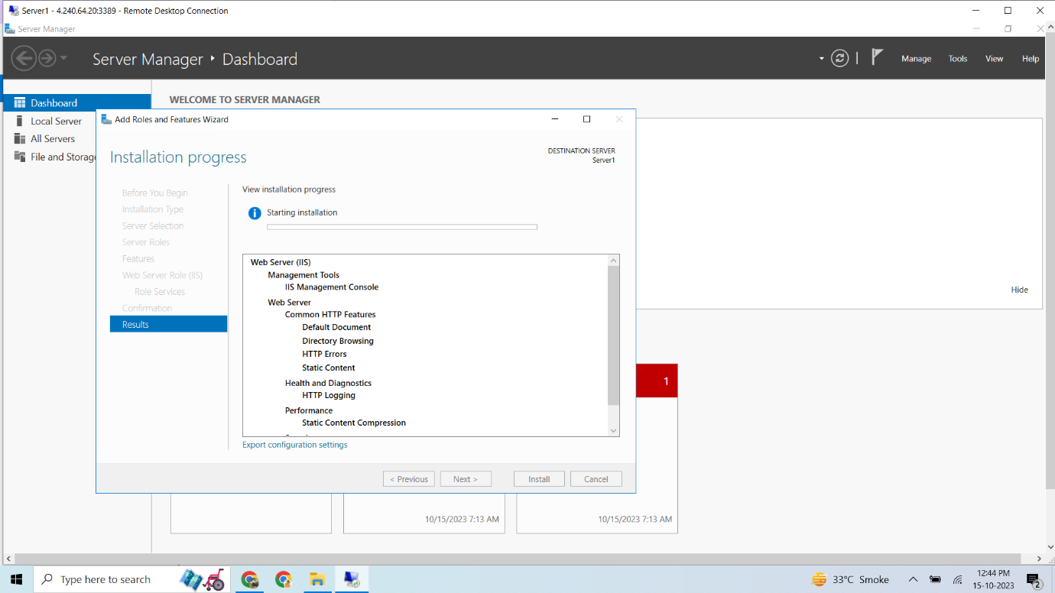

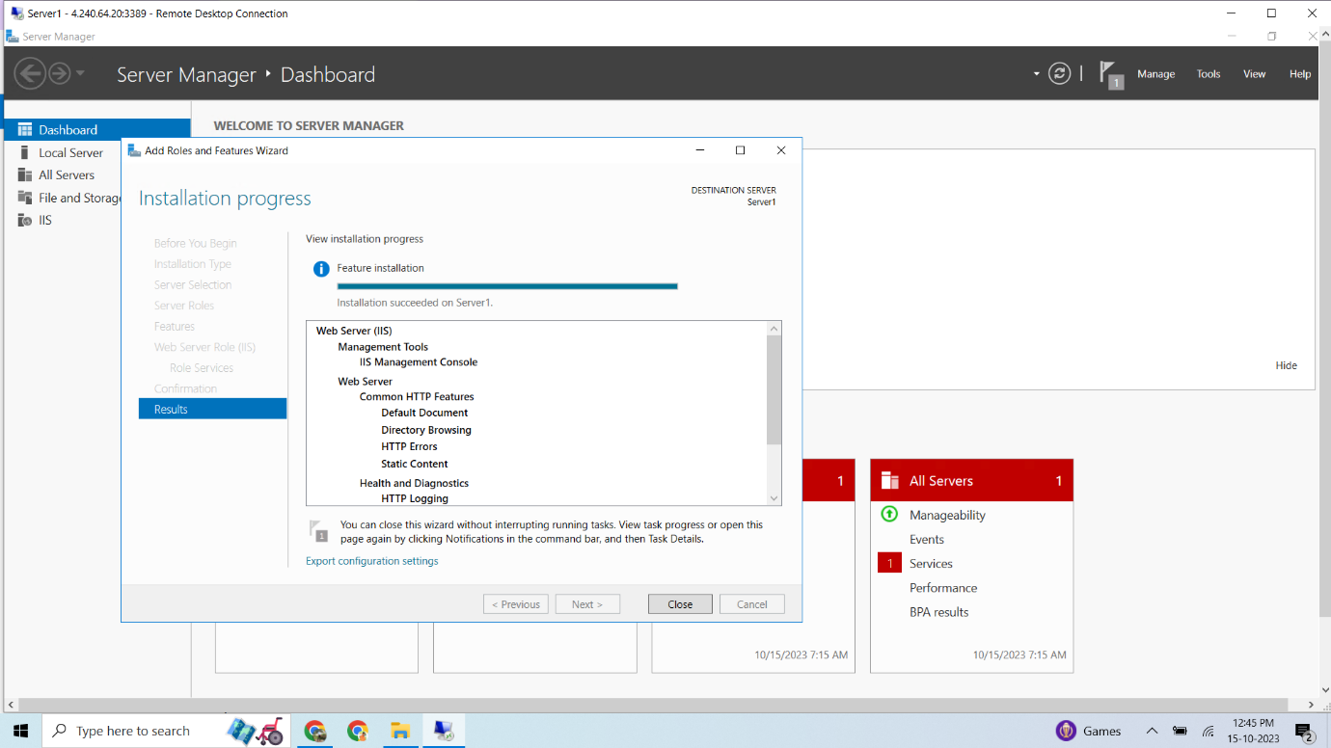

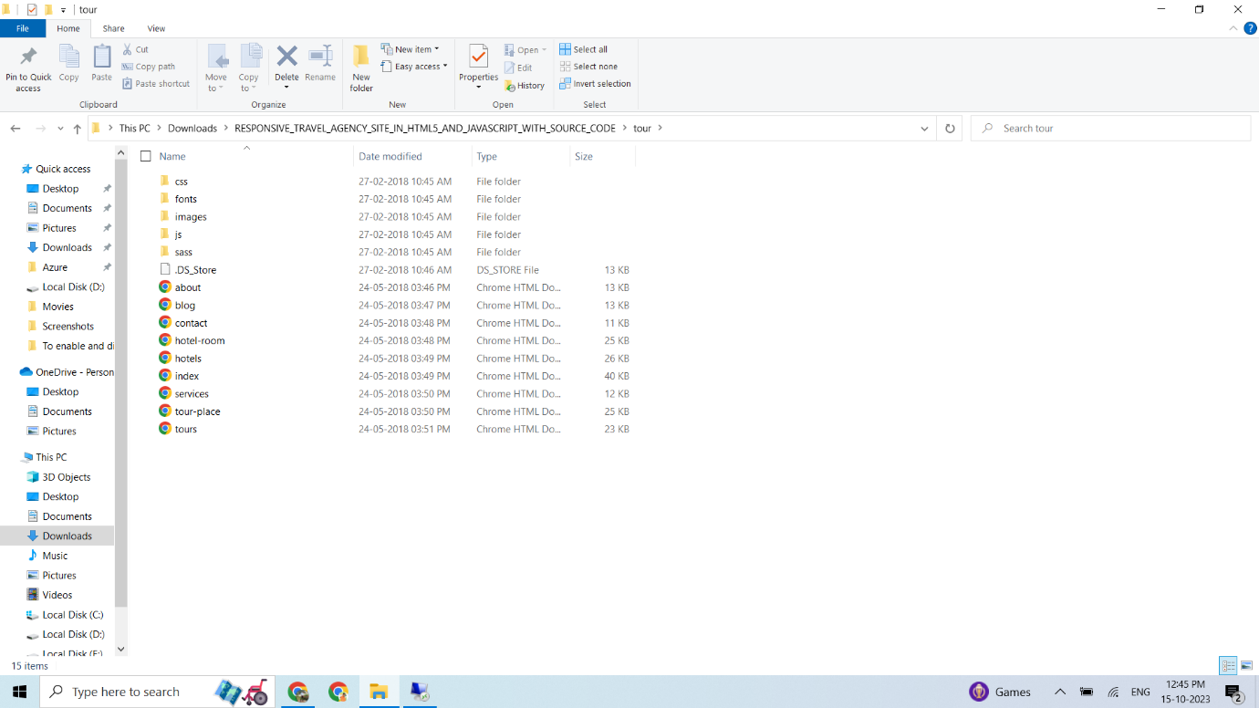Now, we copy the all website files.

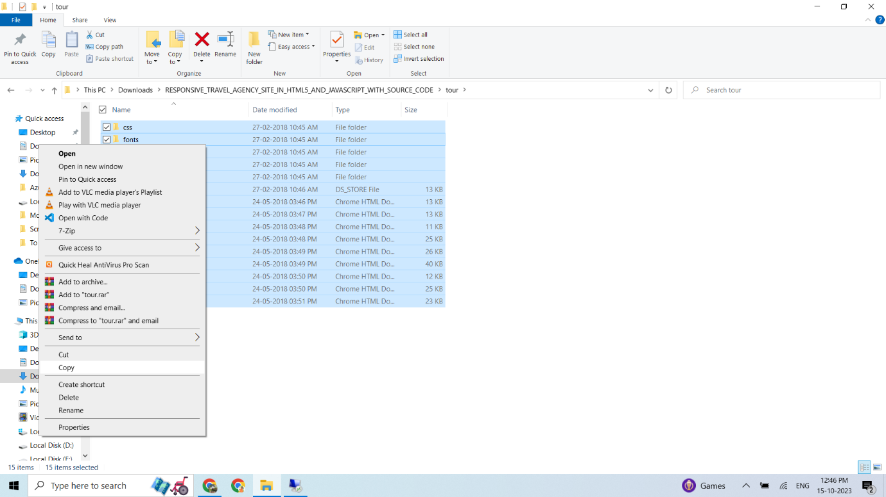

We paste copied files to the VM. (This Pc 🡪 windows 🡪 inetpub 🡪wwwroot)

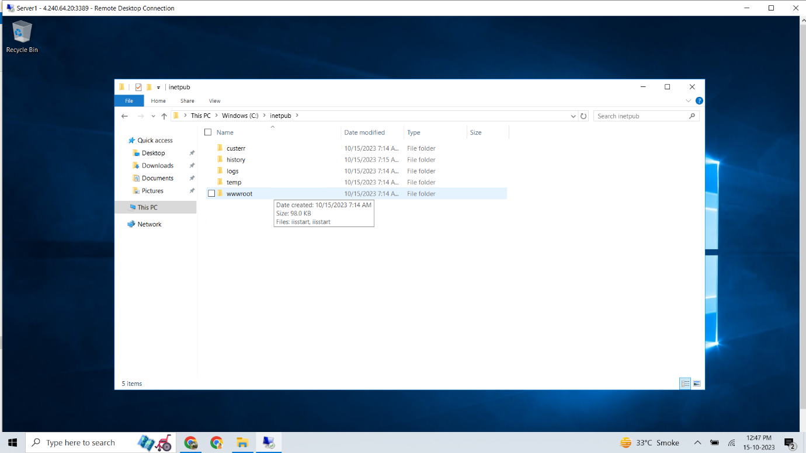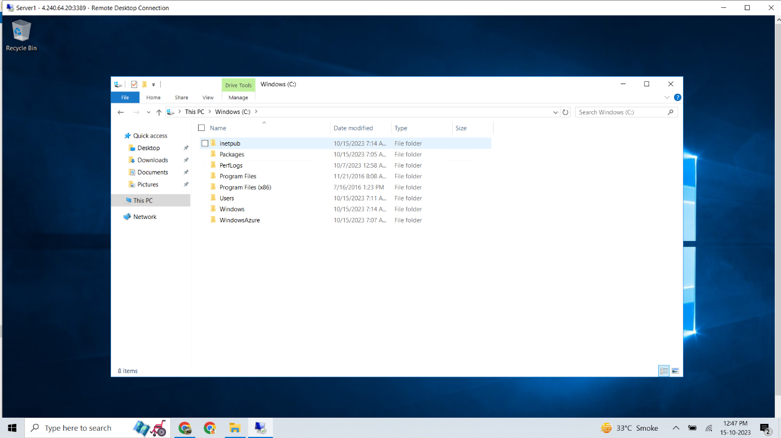

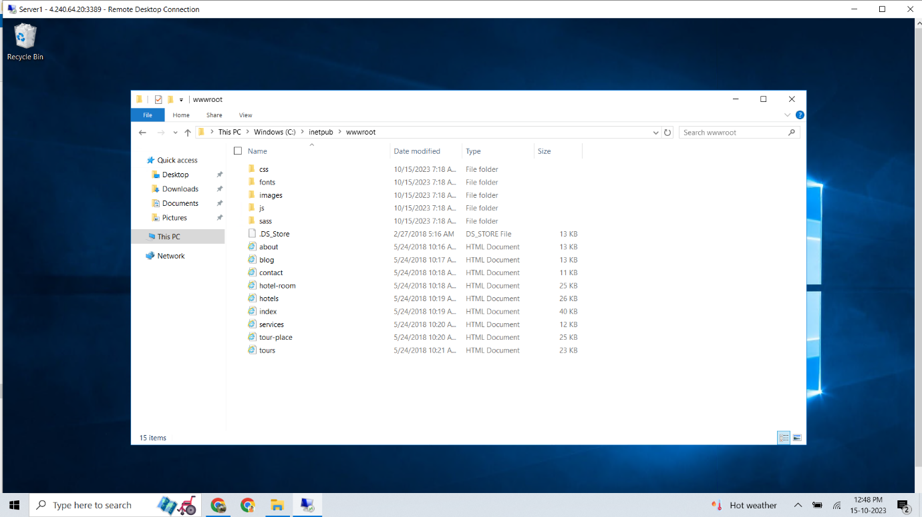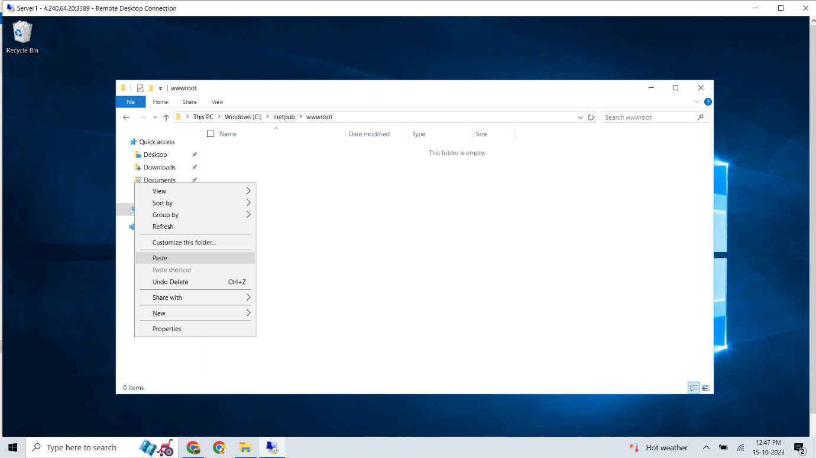

Now we search virtual machine scale seton azure portal.

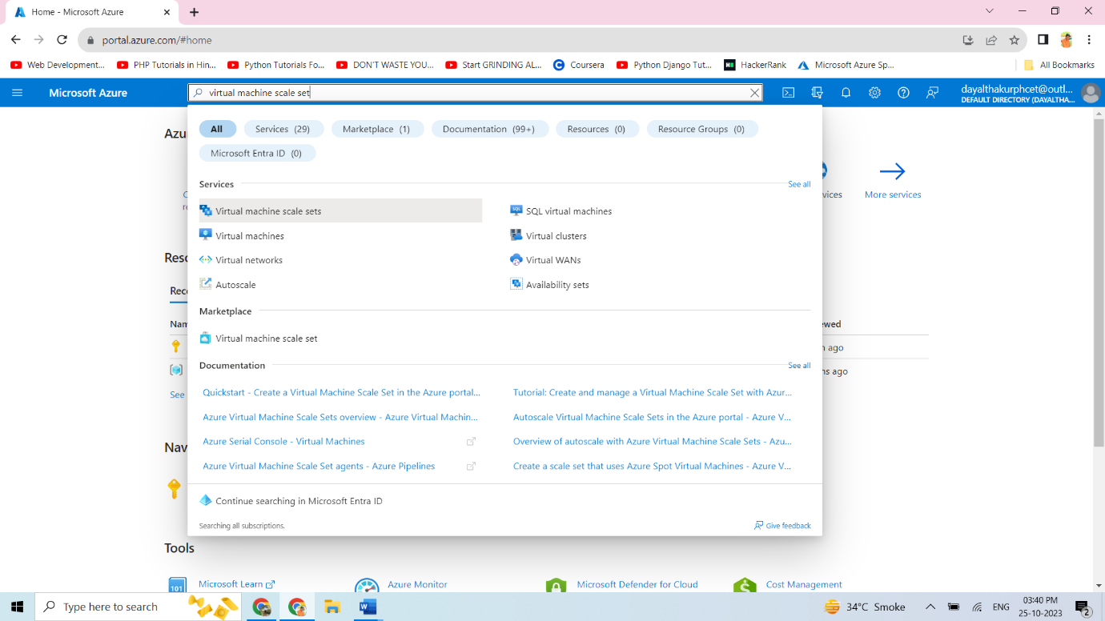

Click on create virtual machine scale set to scale in and scale out the instances.

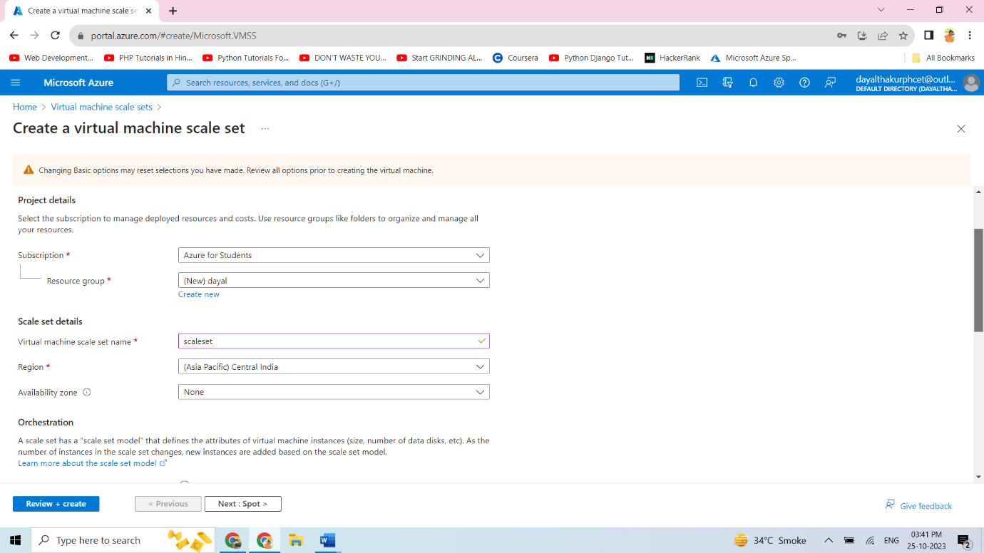

Now search for load balancer, click on the created load balancer

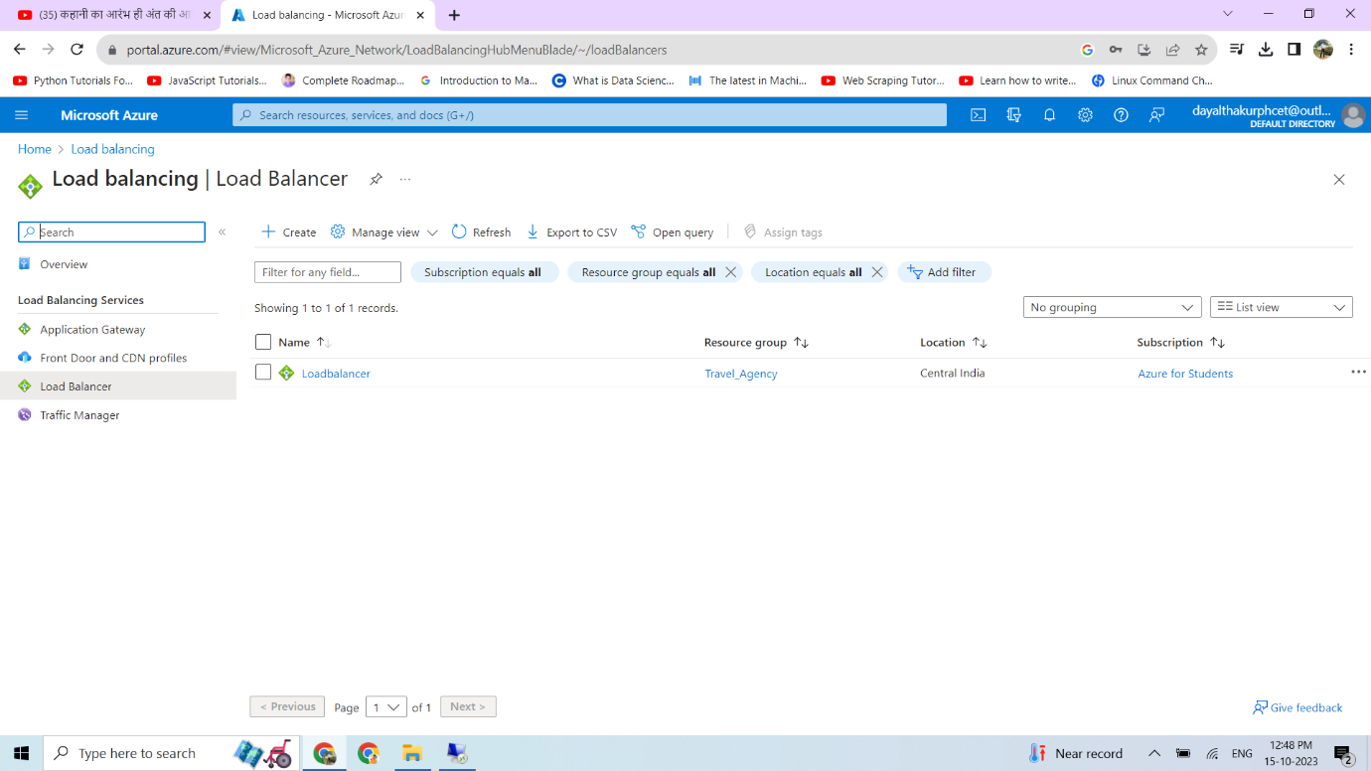

Then click on see more option and copy the load balancer public ip.

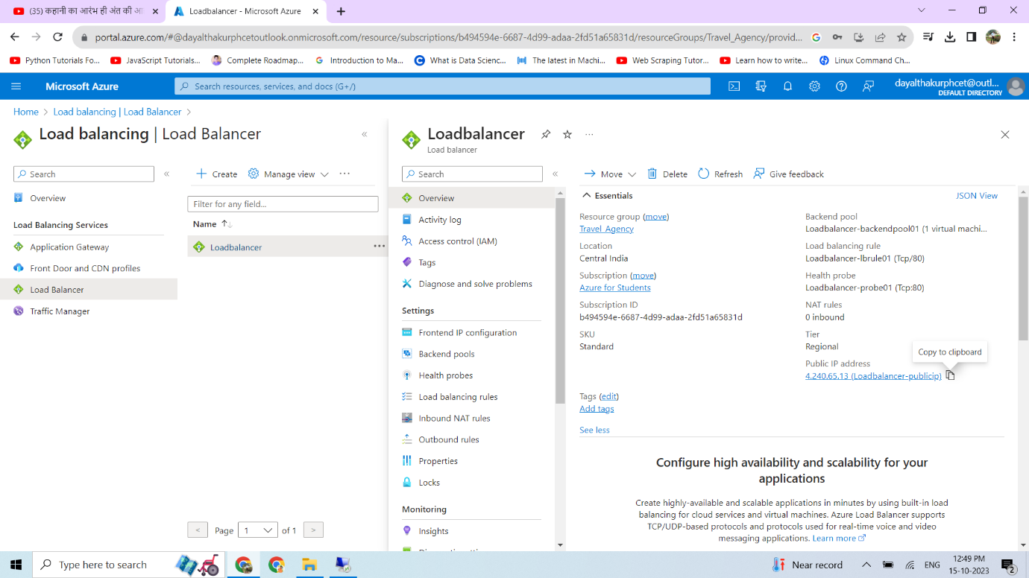

We copied the load balancer public IP and pasted it on google. And we can see the website.

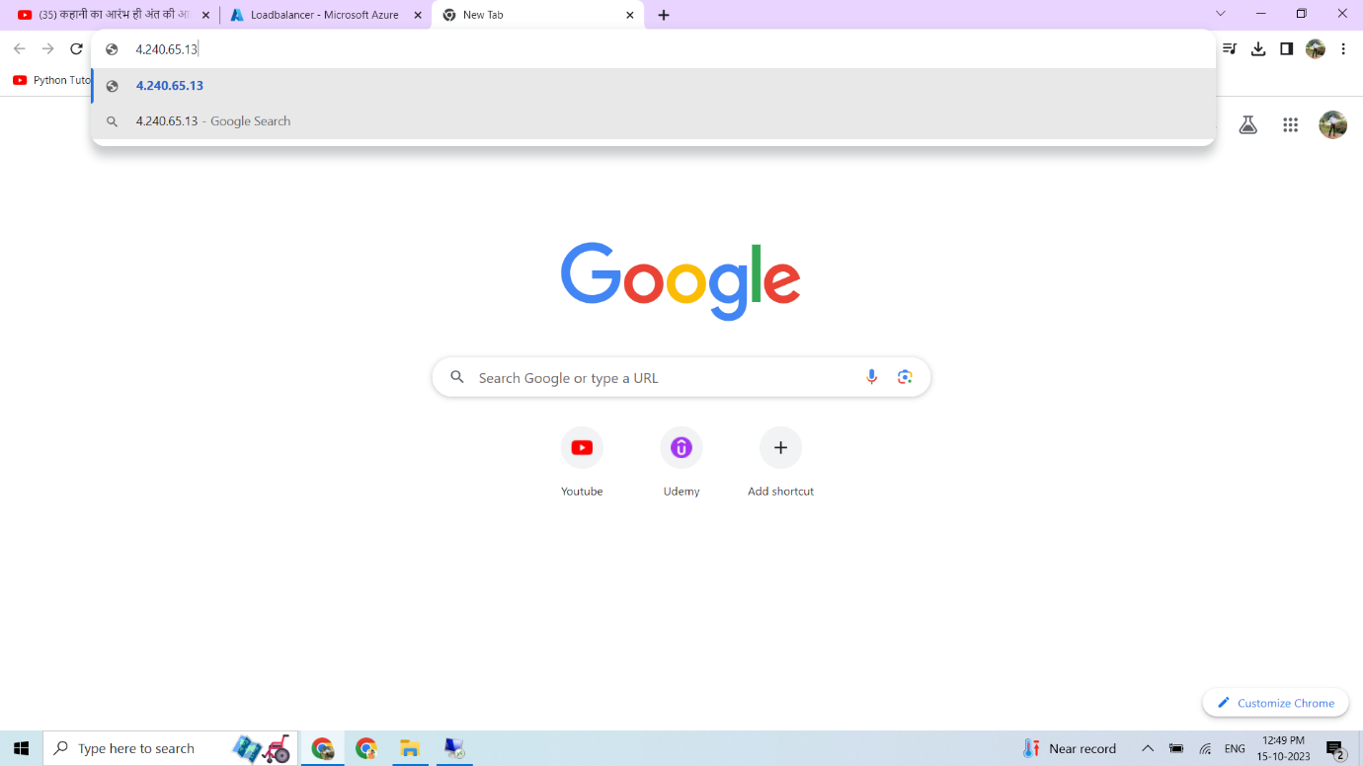

This are the results of our website “Travel Agency”

